# Power Platform Fusion Development

If you don’t already have one, get a Power Apps account at [Business Apps | Microsoft Power Apps](https://powerapps.microsoft.com/en-gb/) This is a 30 day licence which allows you to use premium features such as Dataverse, environments and custom connectors.

Sign on to Azure.

Create an APIM instance if you don’t already have one:

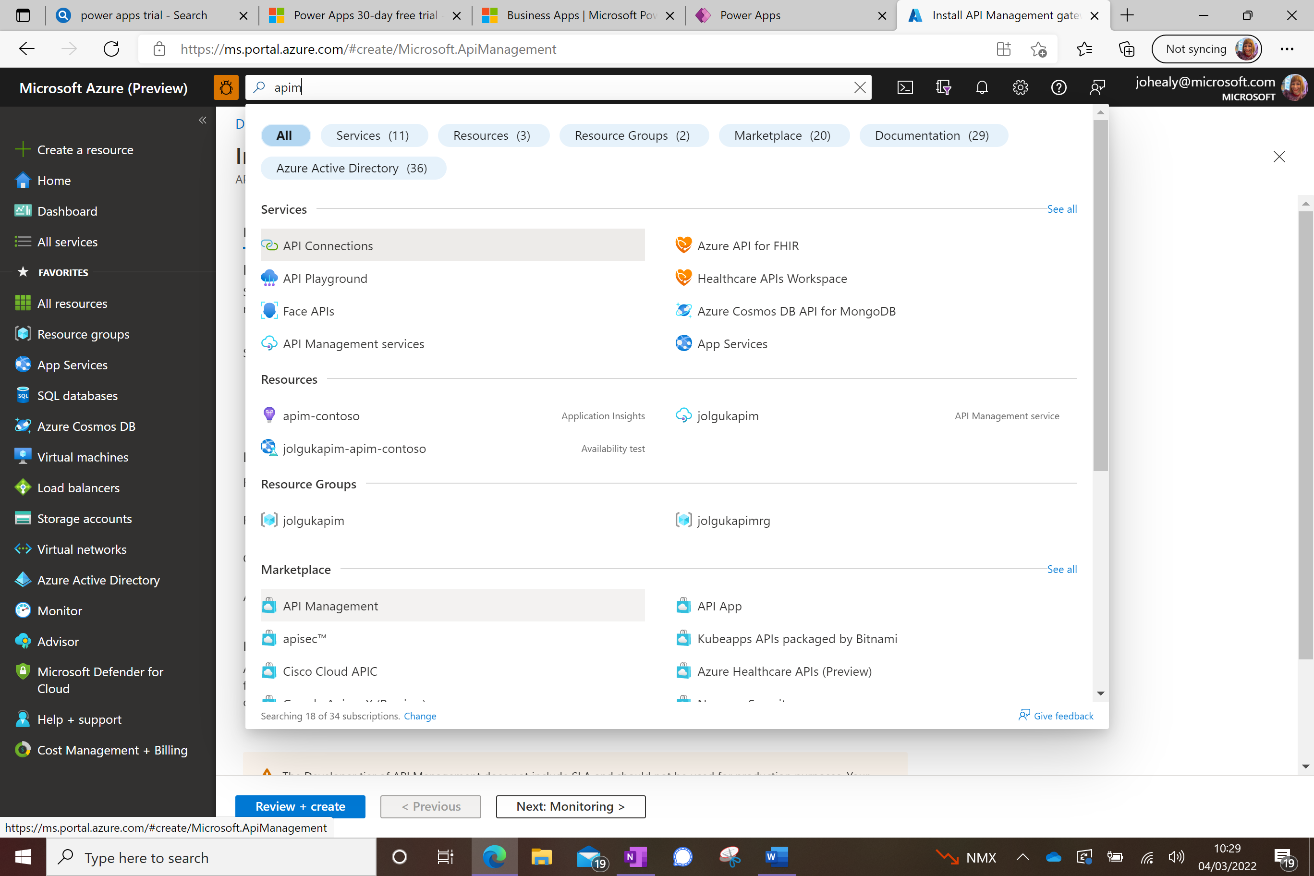

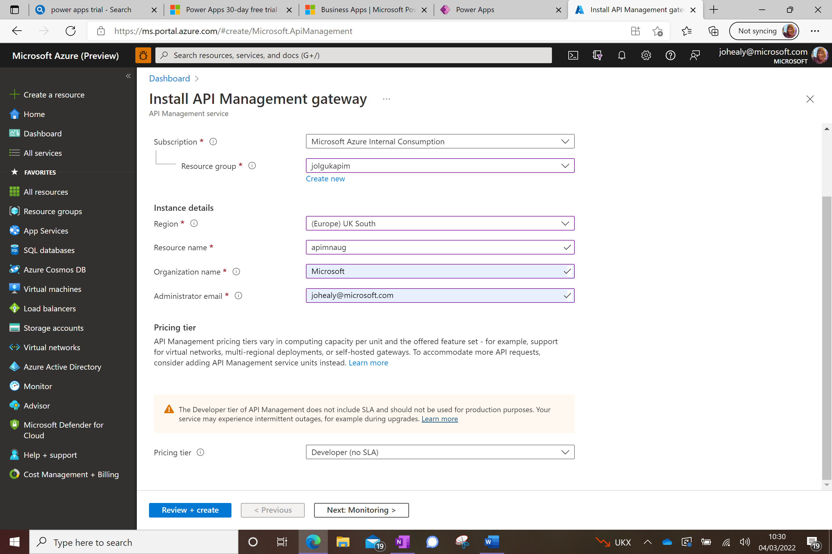

You can use the free developer tier for this but be warned that this takes quite a while to provision. Press Review And Create.

Go to your APIM instance, and click APIs on the left:

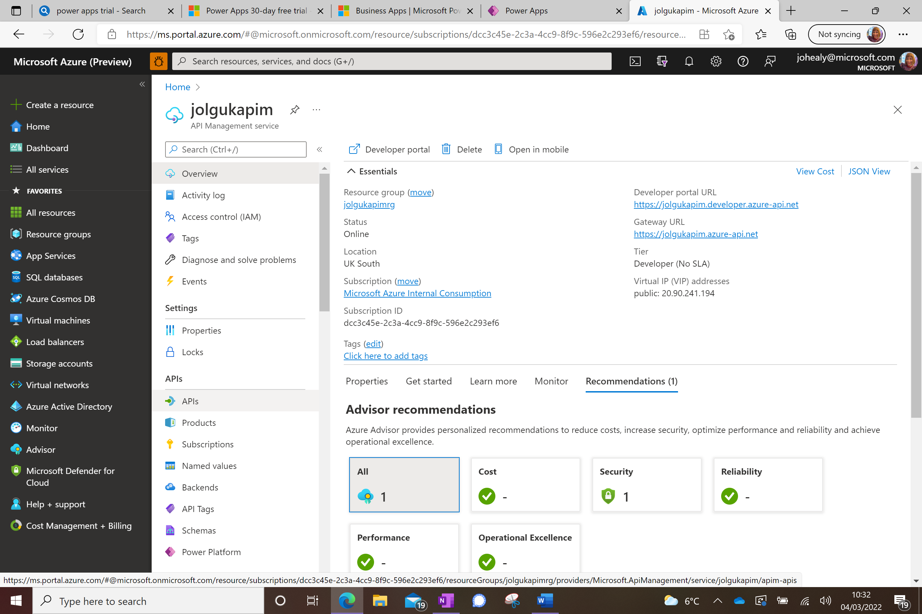

Click the HTTP section:

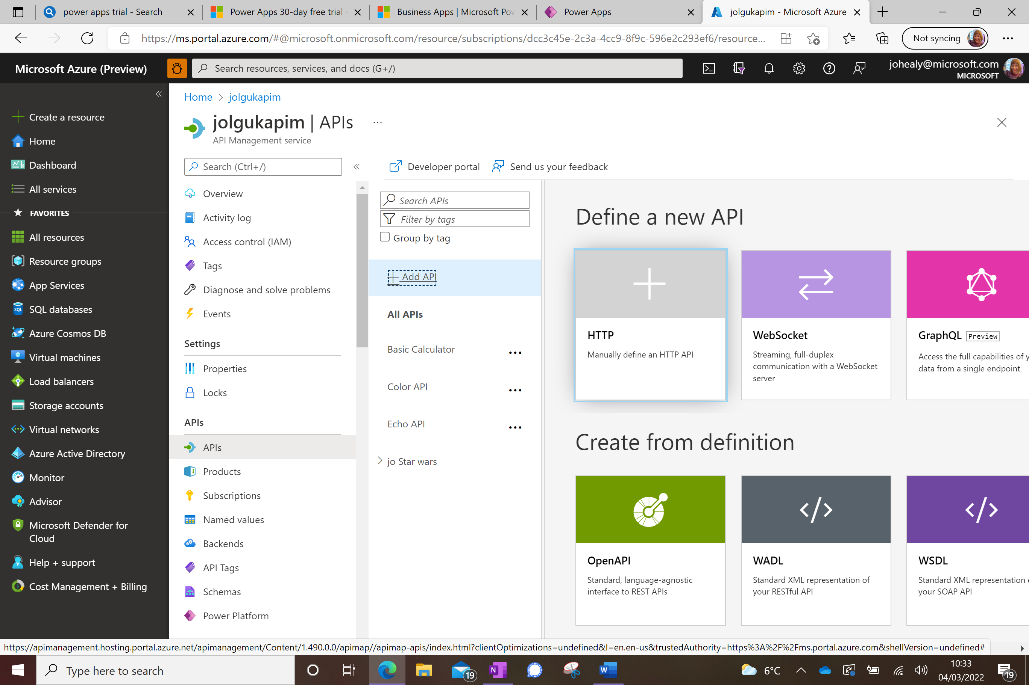

Select Full rather than Basic and fill out the details, using the Star Wars API <https://swapi.dev/api/> as the web service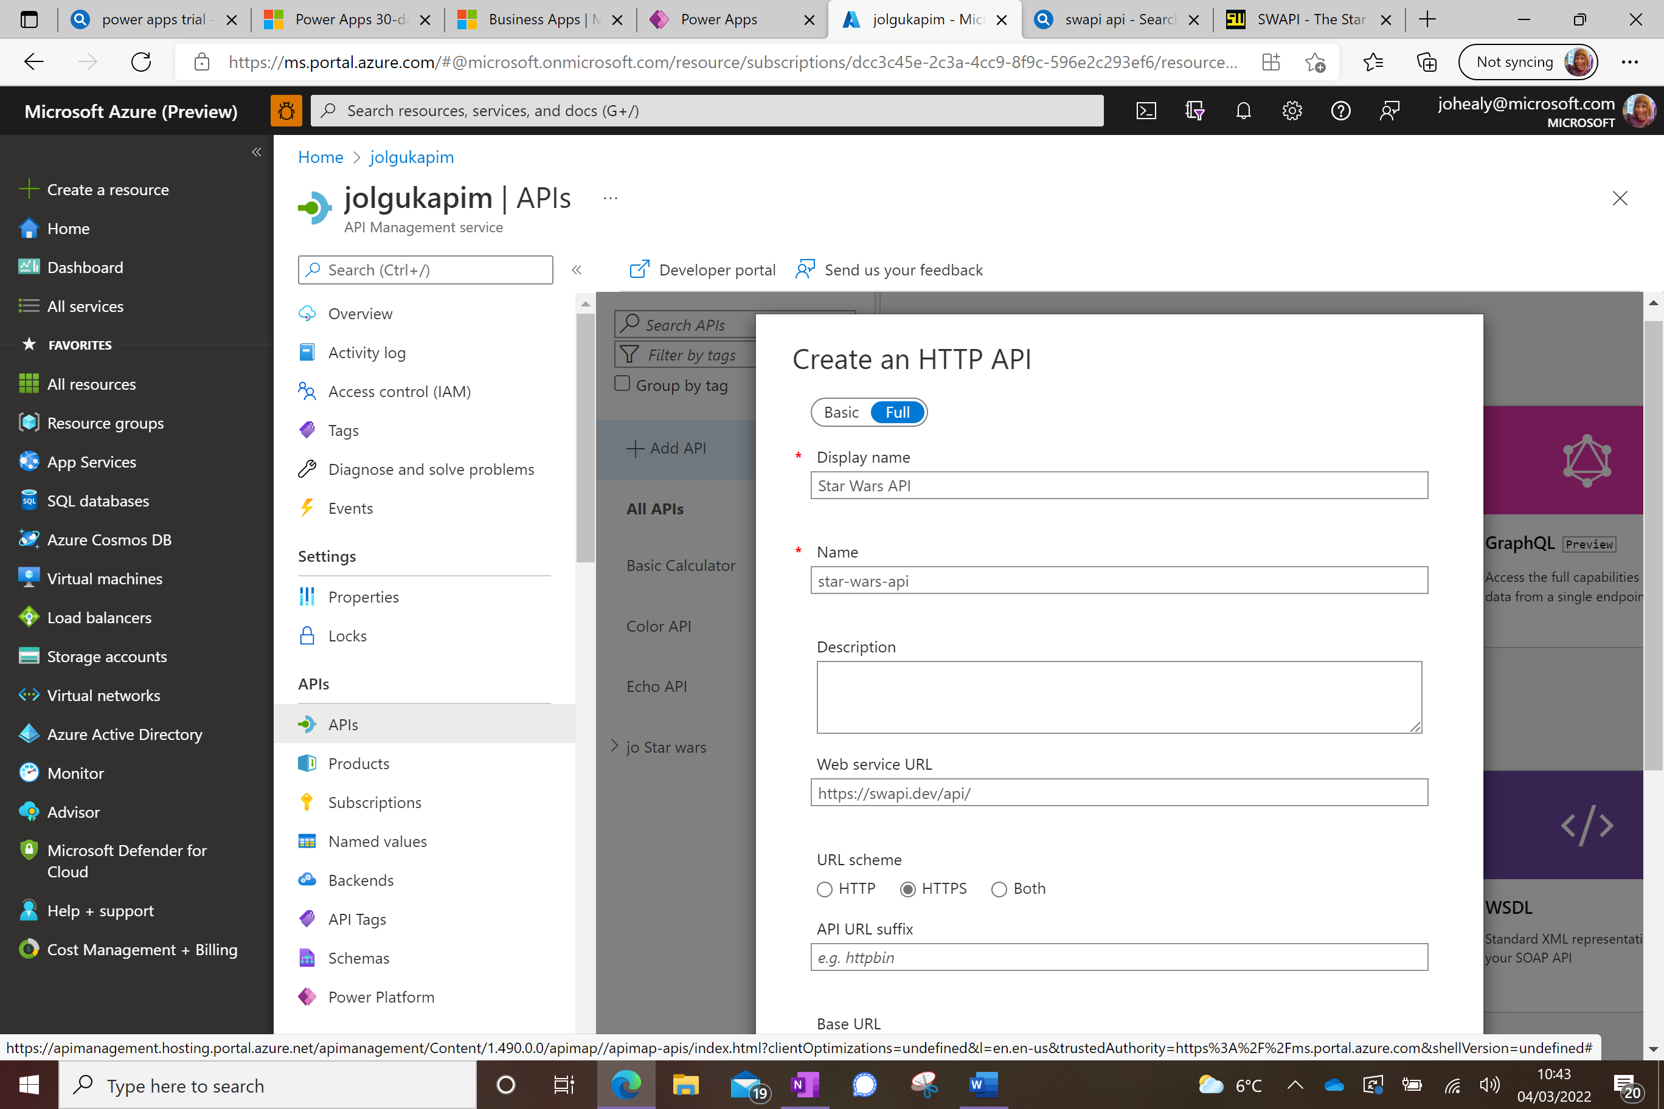

In the Products box select both Starter and Unlimited and leave Gateways at Managed. Press Create.

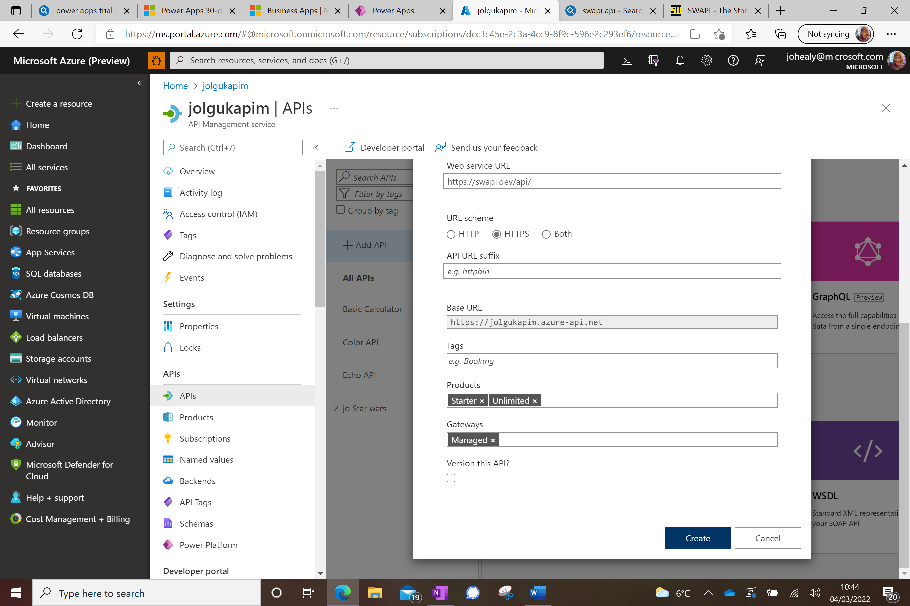

Once created, go to Settings and untick Subscription required and set the API URL suffix to ‘star’, then press Save.

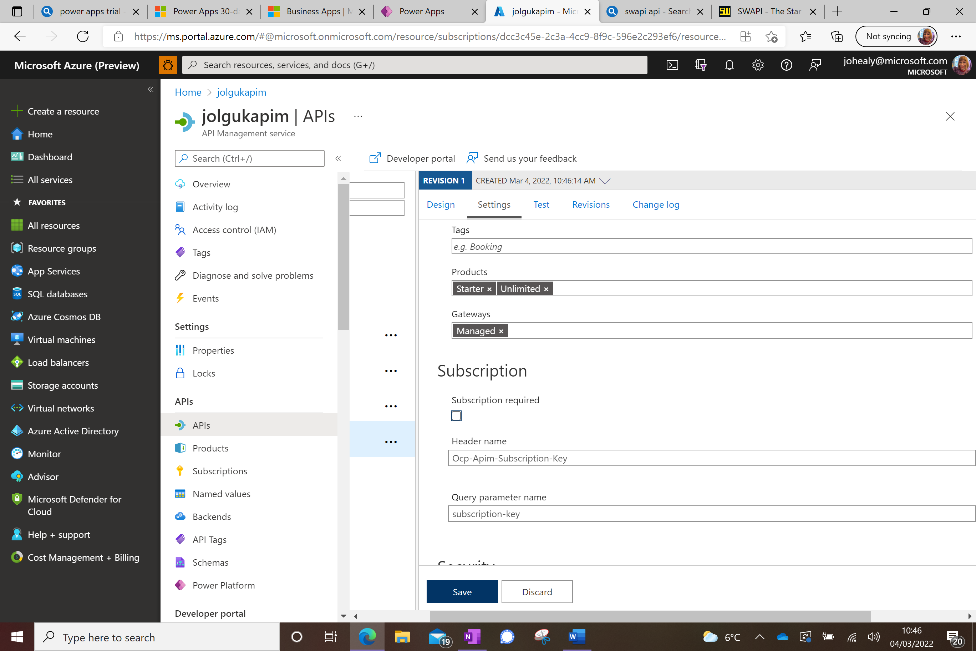

Click on Design and click Add Operation

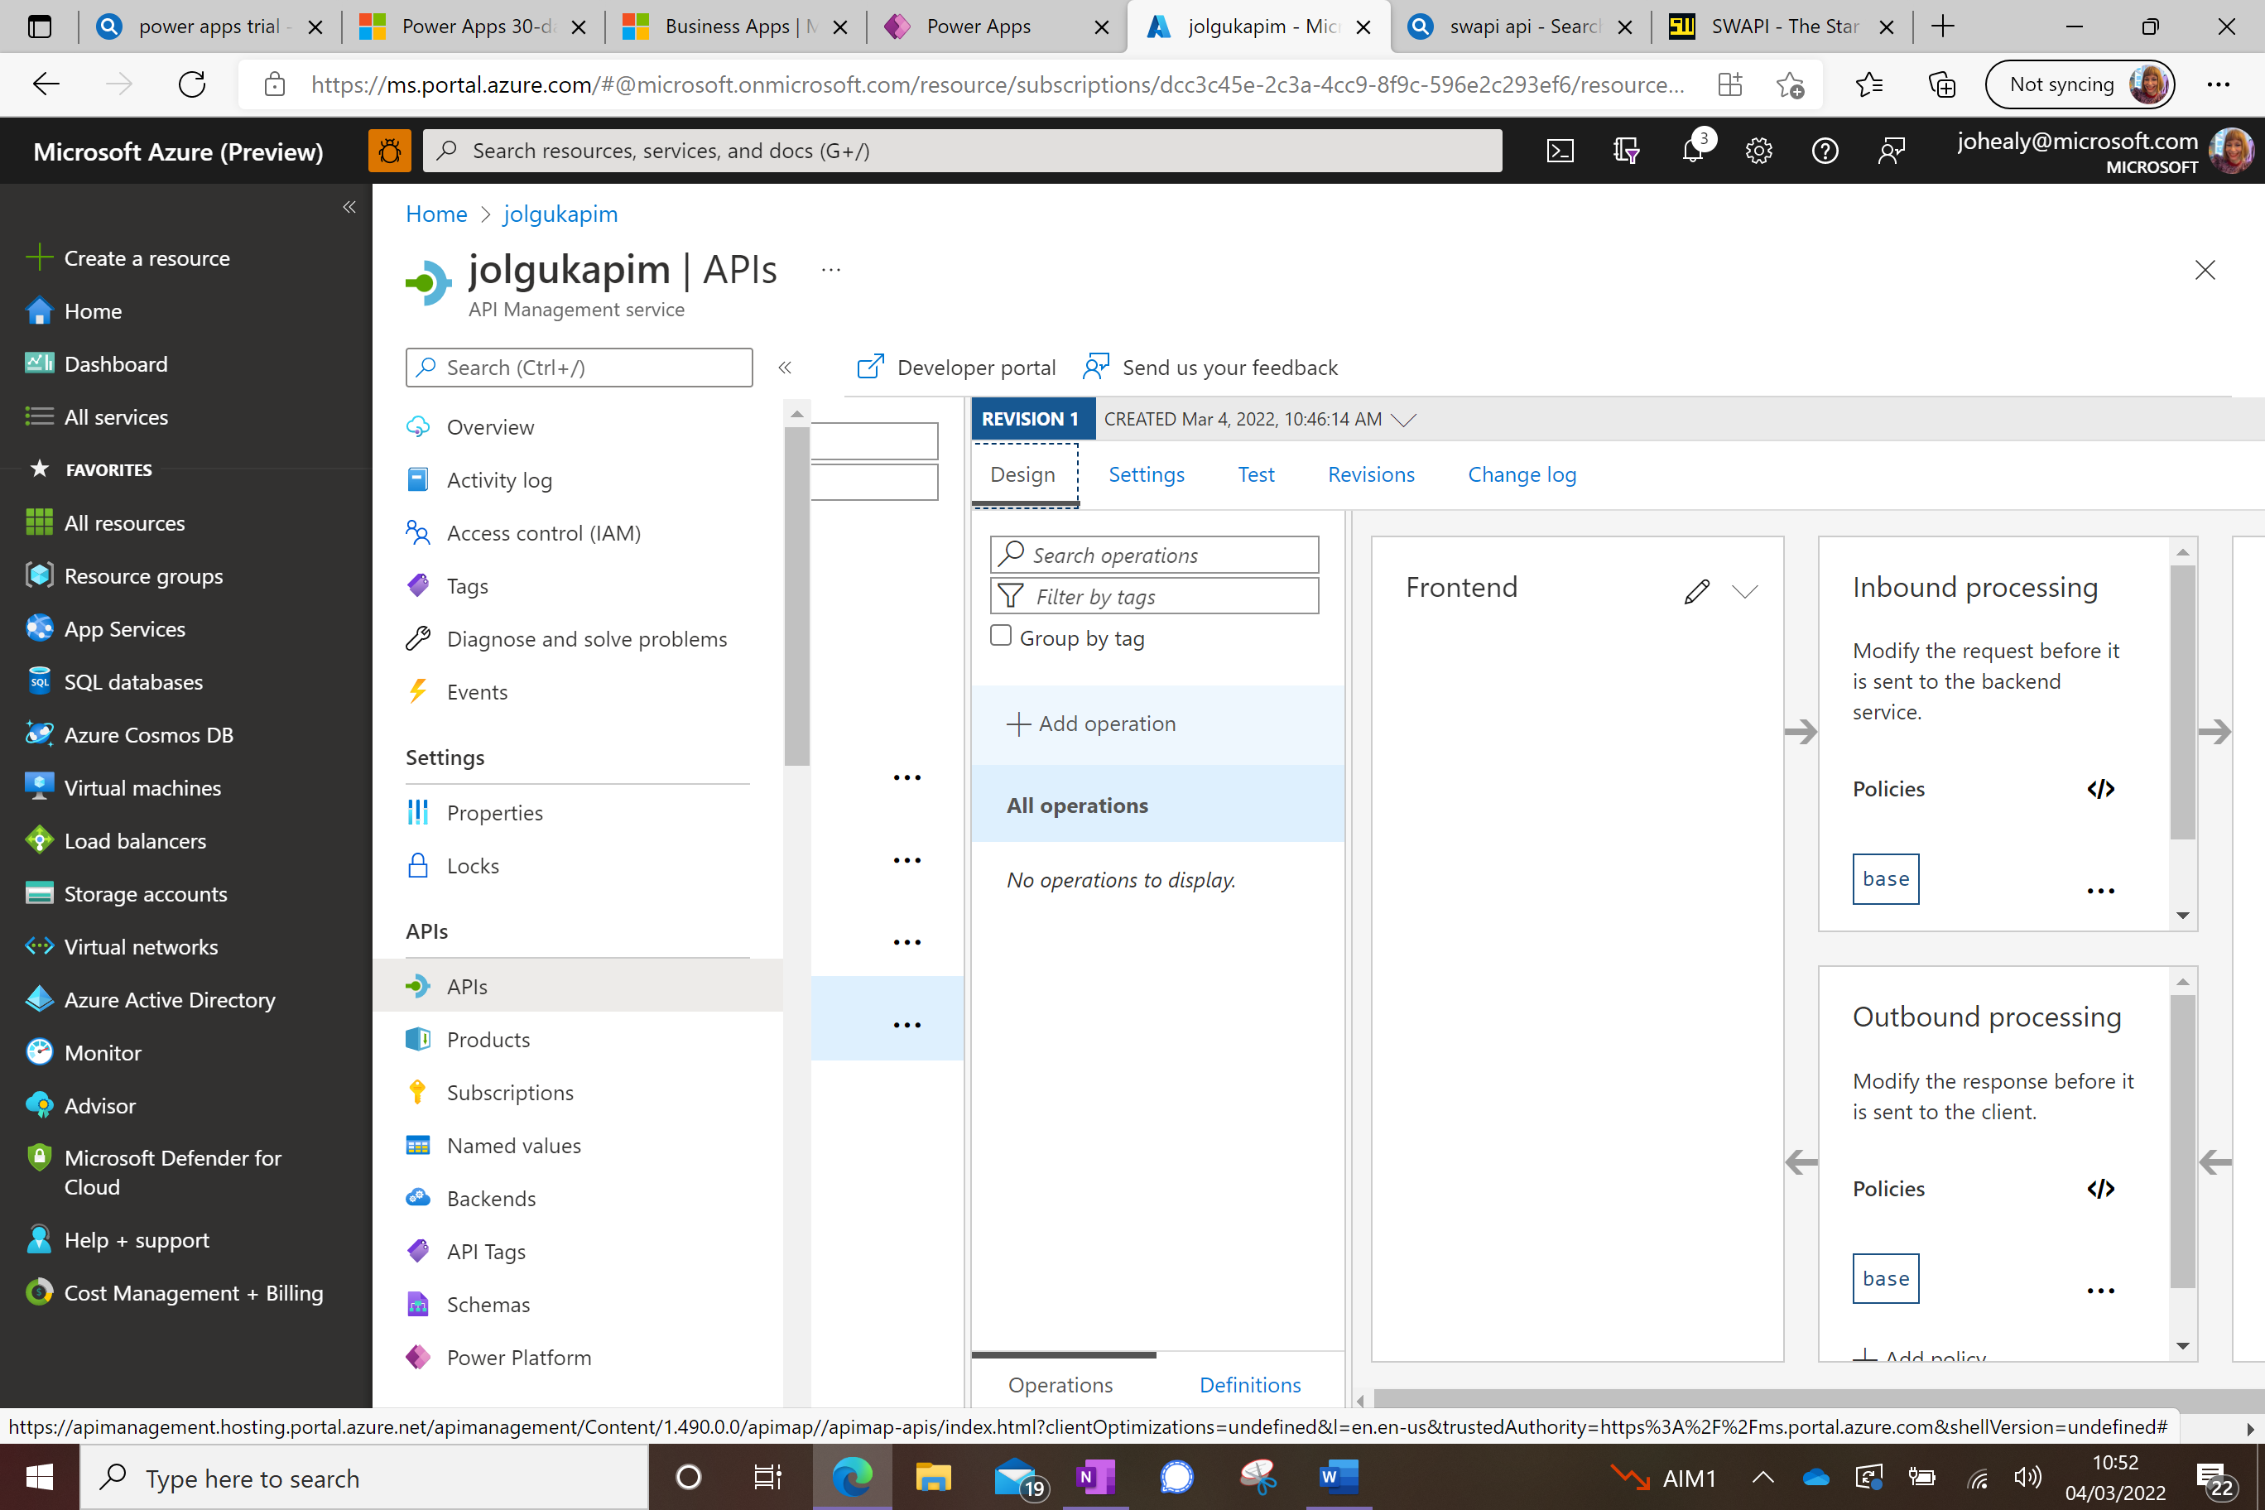

Fill out the GetPeople API as here:

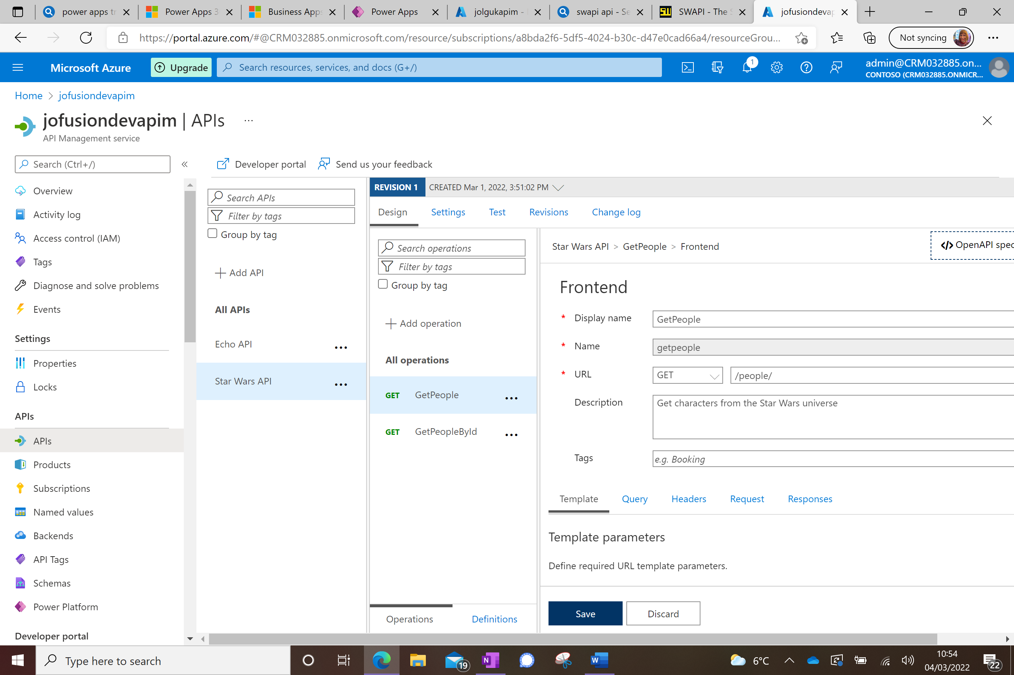

Press Save

Press Test and Send

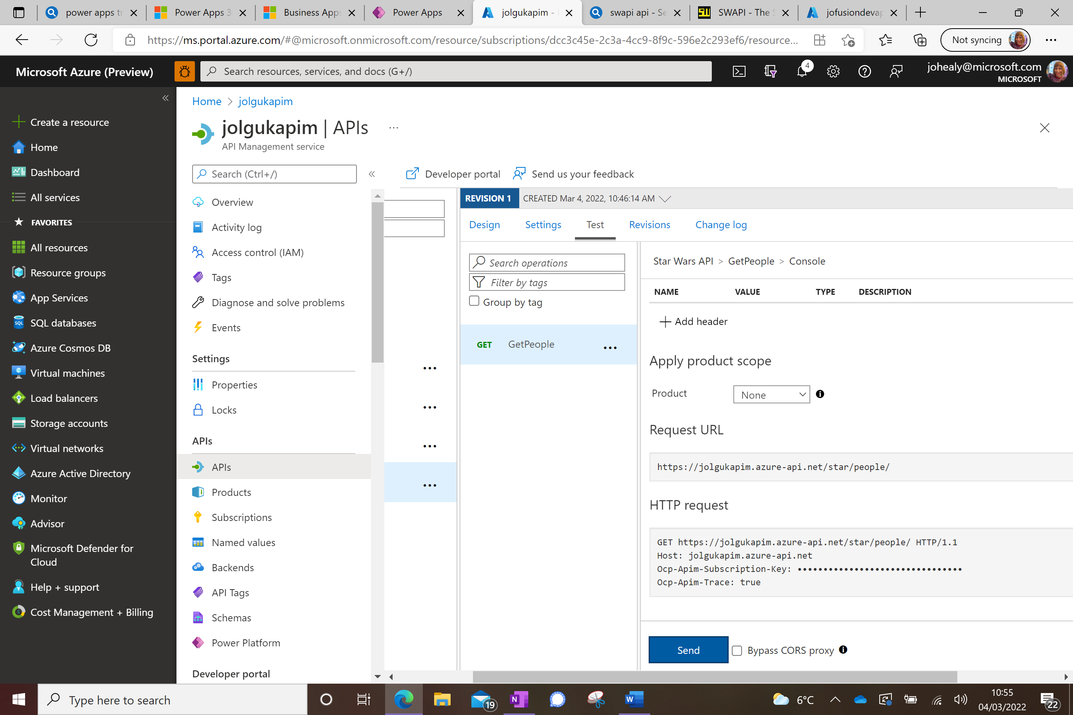

You should get a successful 200 response

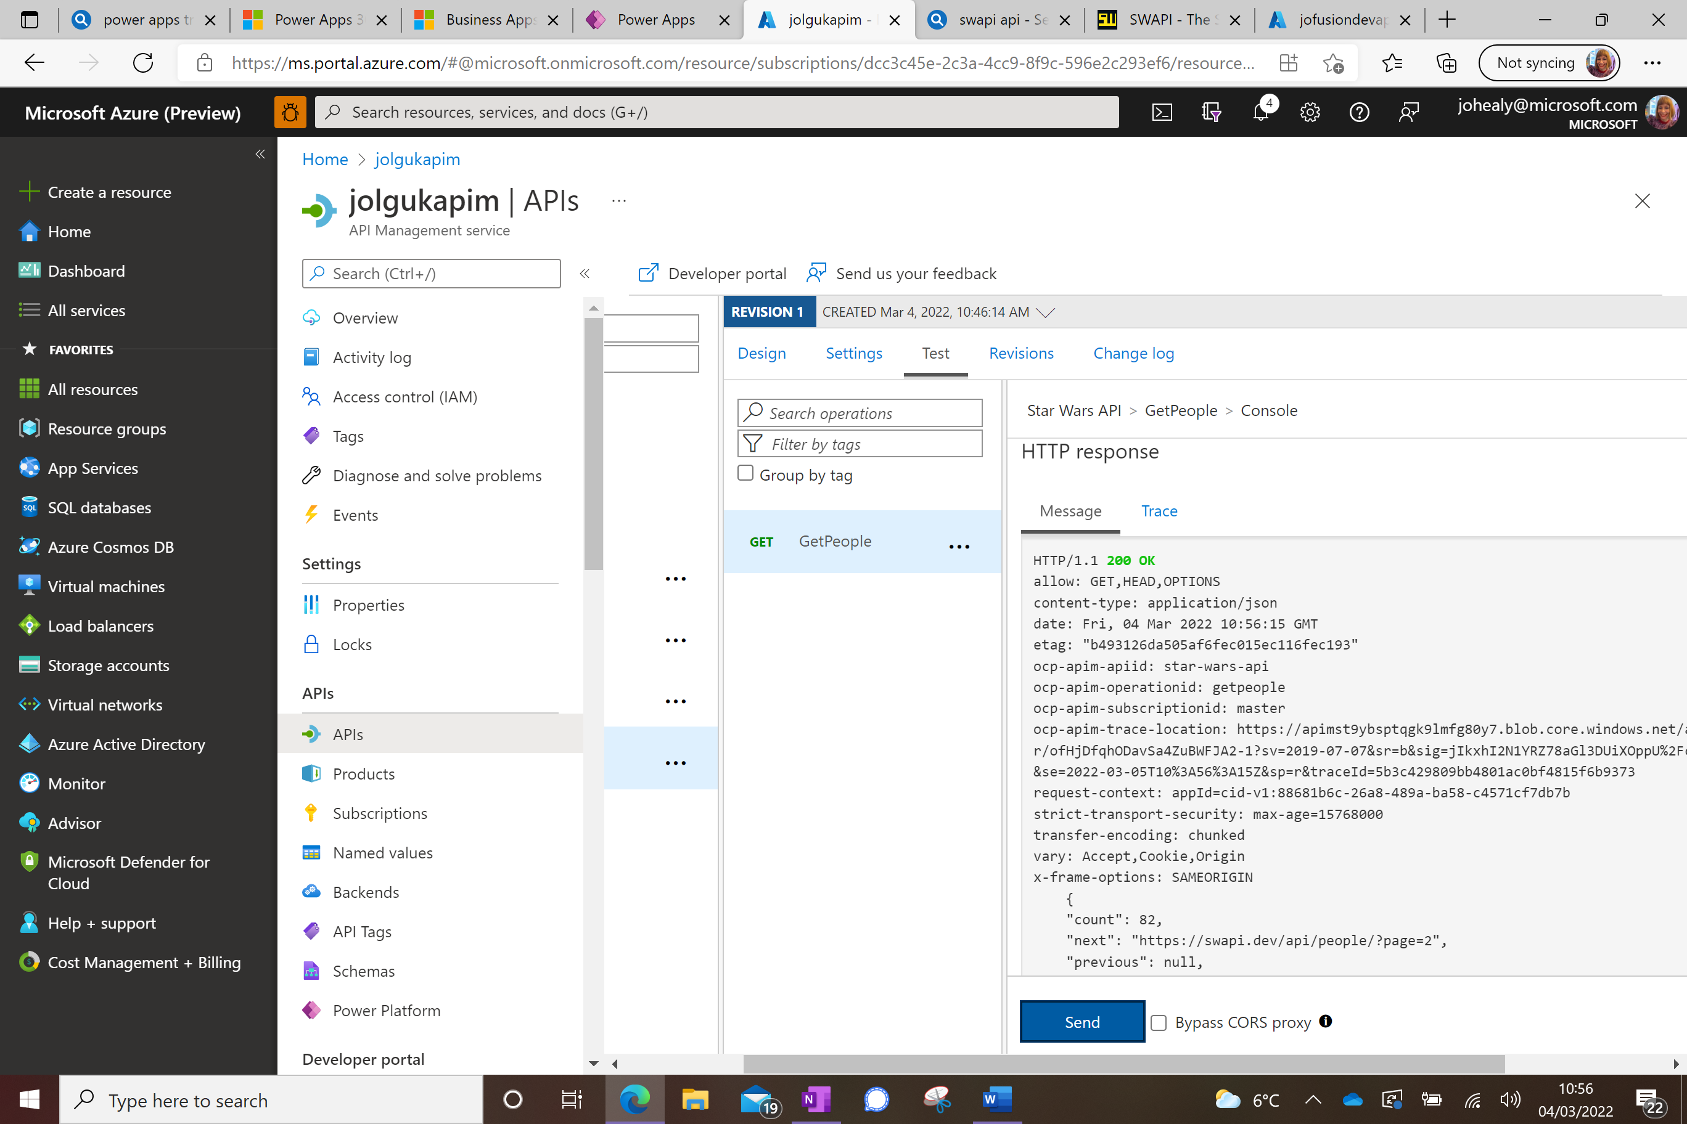

Now export the API to Power Platform;

Scroll to the left so your API is visible again and then select the Elipsis (3 dots) next to it, and then select Export. (If you are using Azure within the same tenant as Power Platform you could use the Create Power Connector method instead).

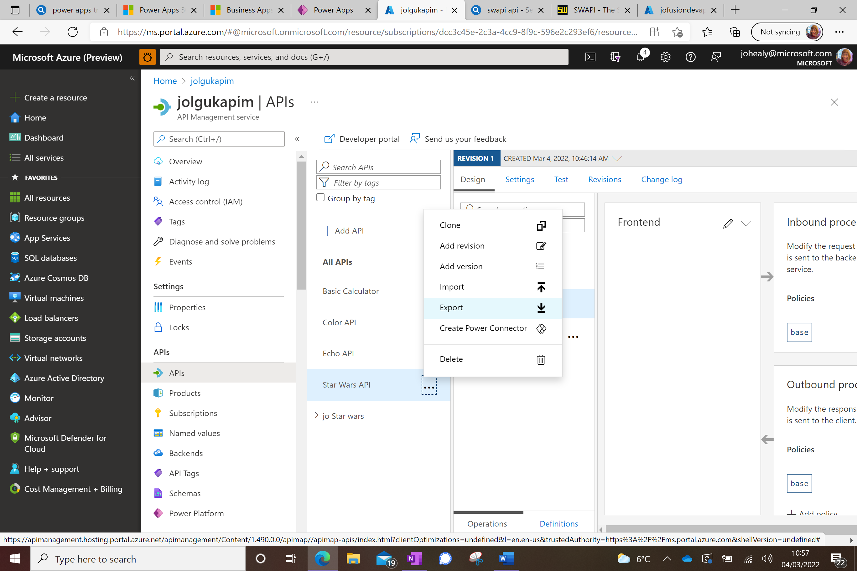

Choose OpenAPIv2 (JSON)

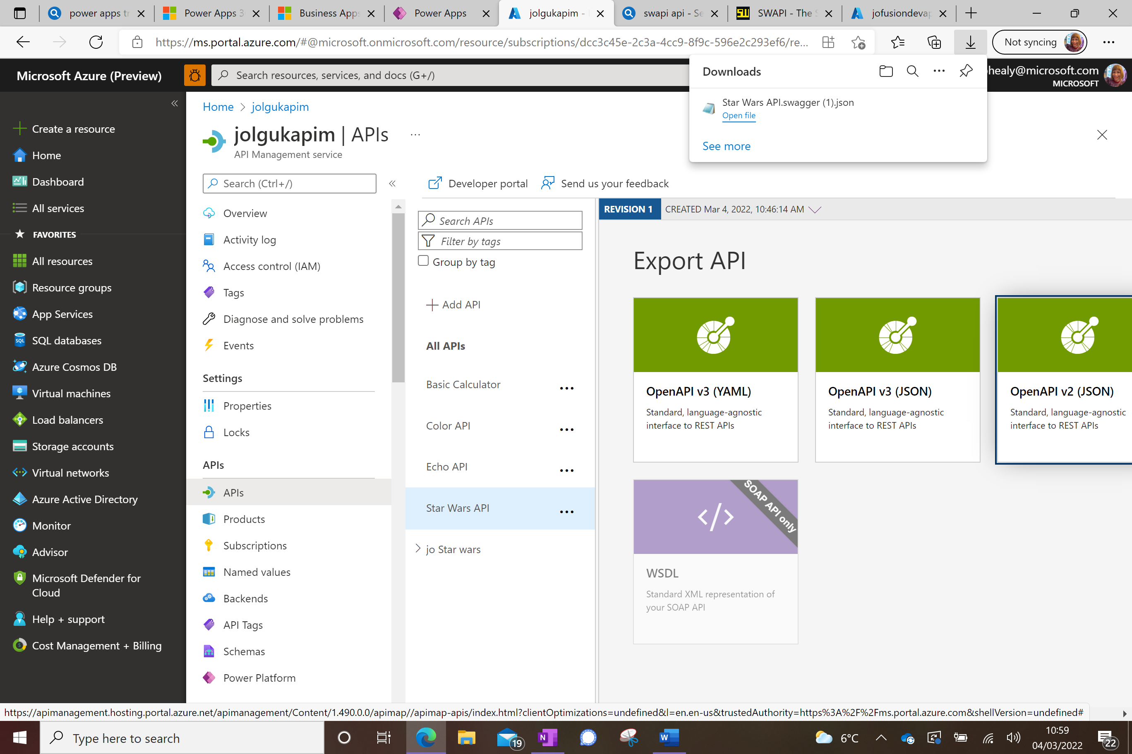

Now sign onto Power Platform at make.powerapps.com

On the left choose Data then Custom Connectors

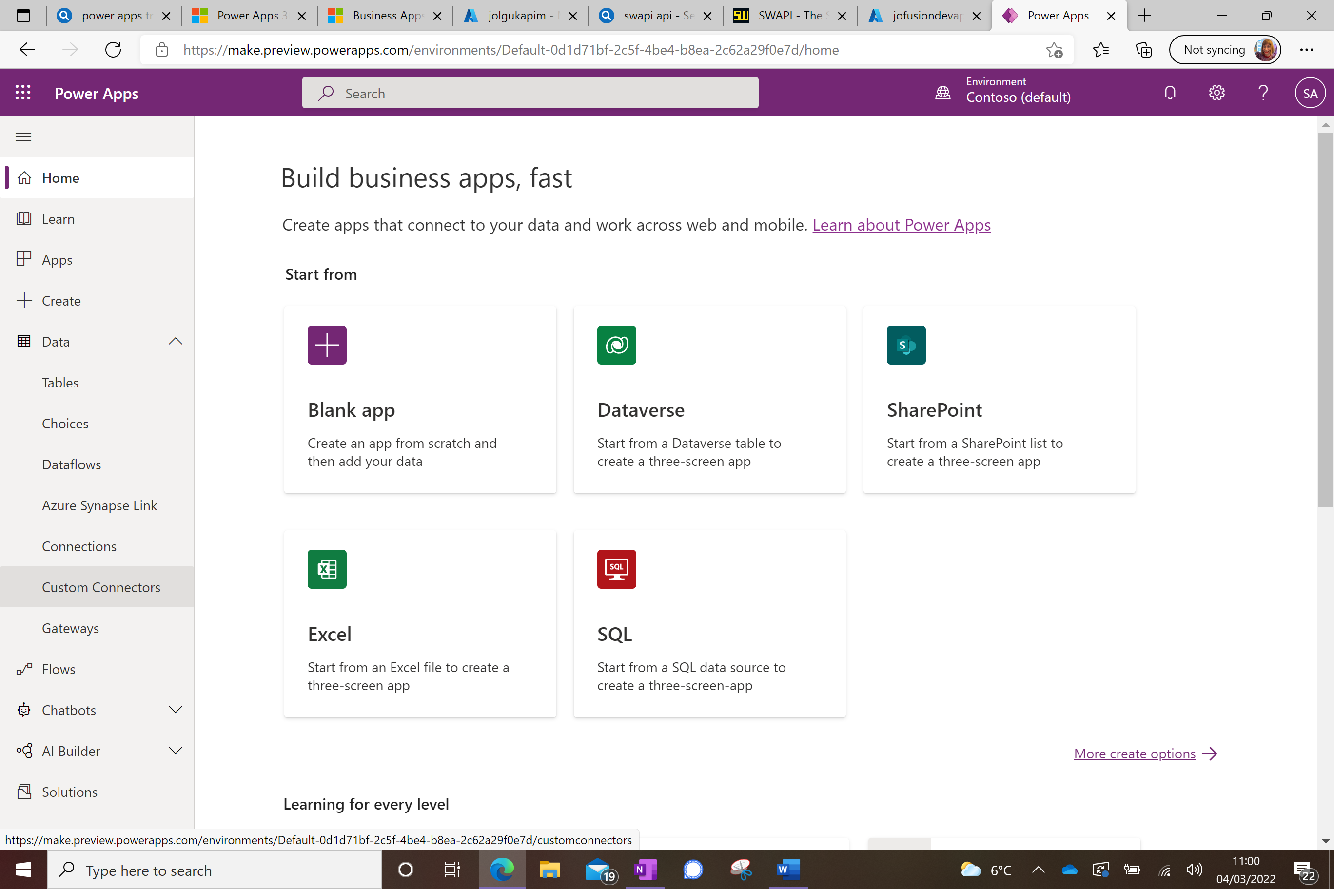

Choose New Custom Connector at the top right,

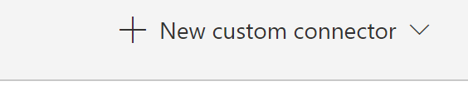

Choose Import an OpenAPI file and select the json file you just downloaded.

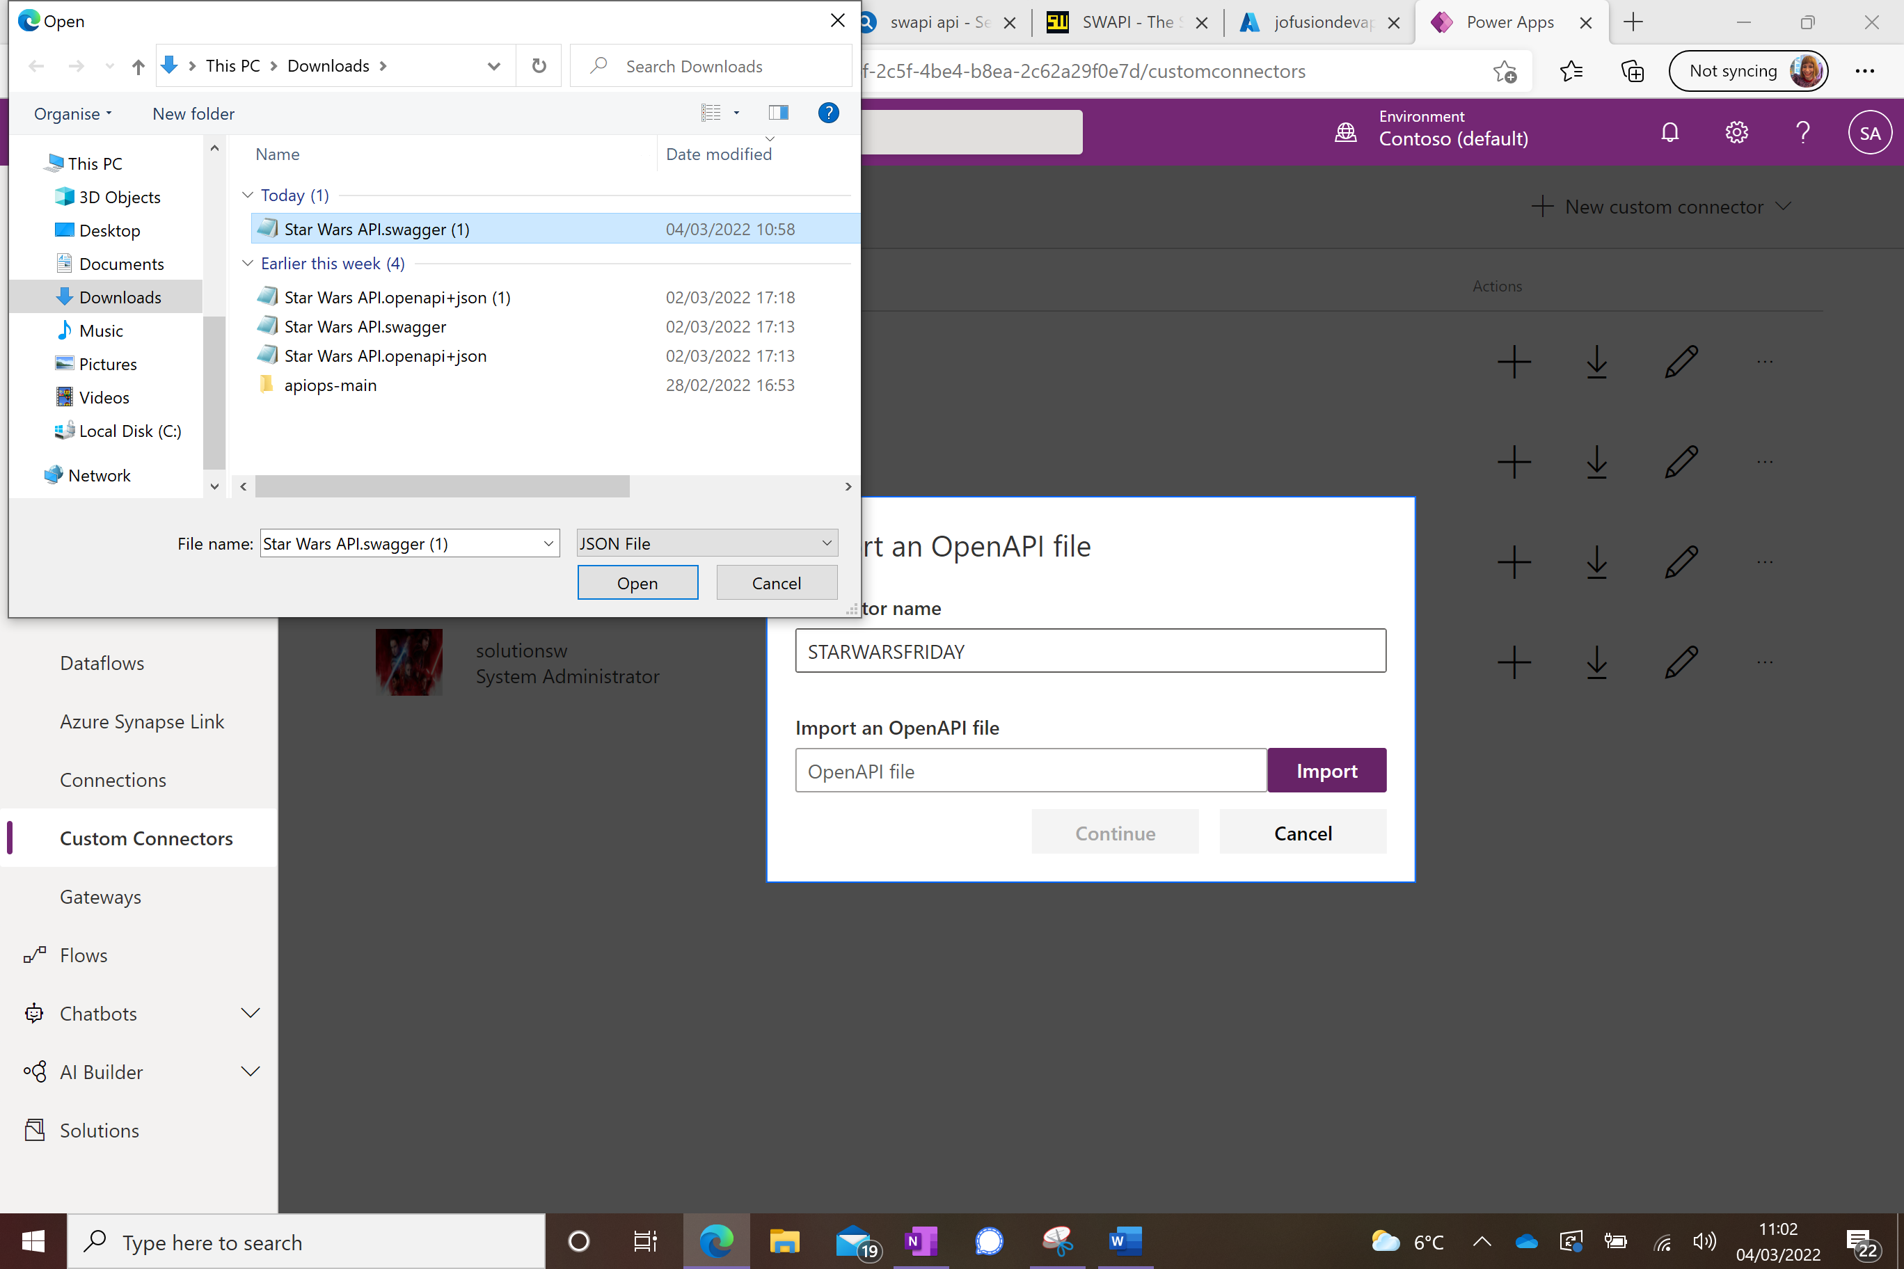

Press Continue

Add an icon for your connector (an image from your computer) and add a description

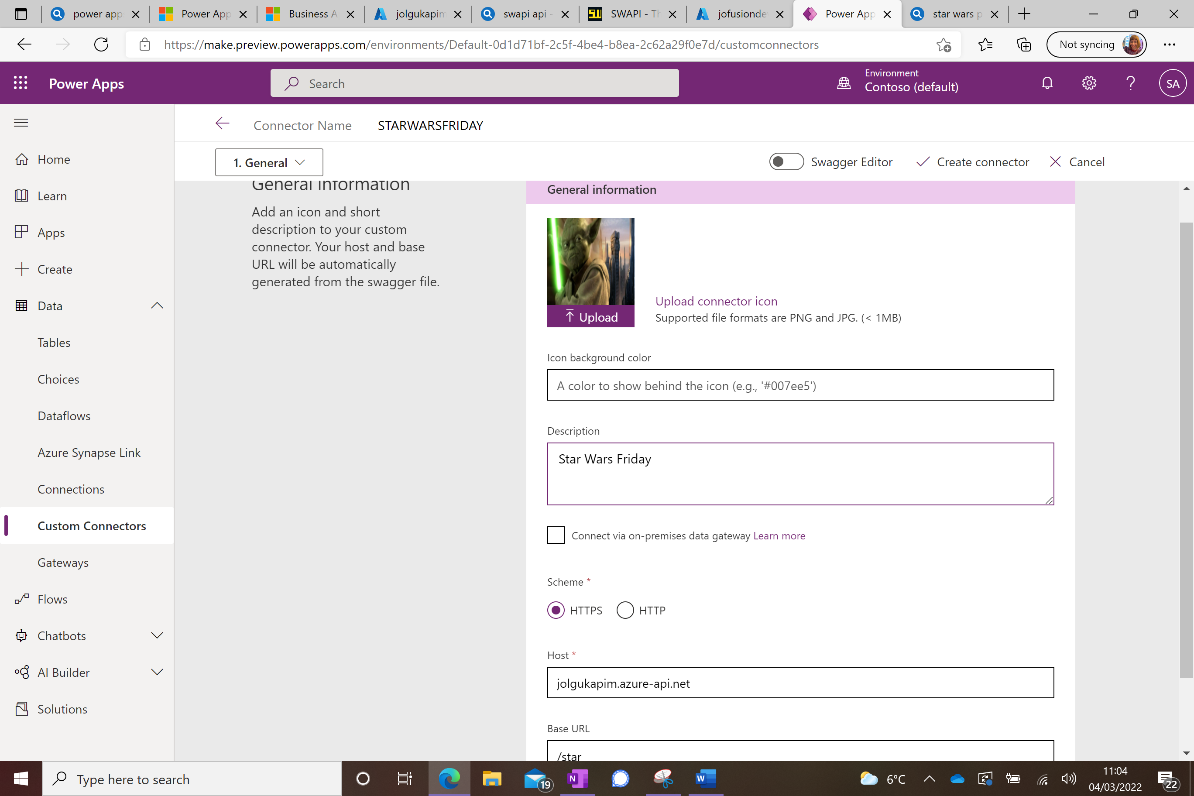

Press the arrow next to Security at the bottom right

Change the Authentication type on the next screen to no authentication and click the arrow next to Definition

Toggle the Swagger Editor on at the top of the screen and replace the contents with the contents of the naug.swagger.json file from the github repository.

Select create connector

You can test the connector in the dropdown on the left

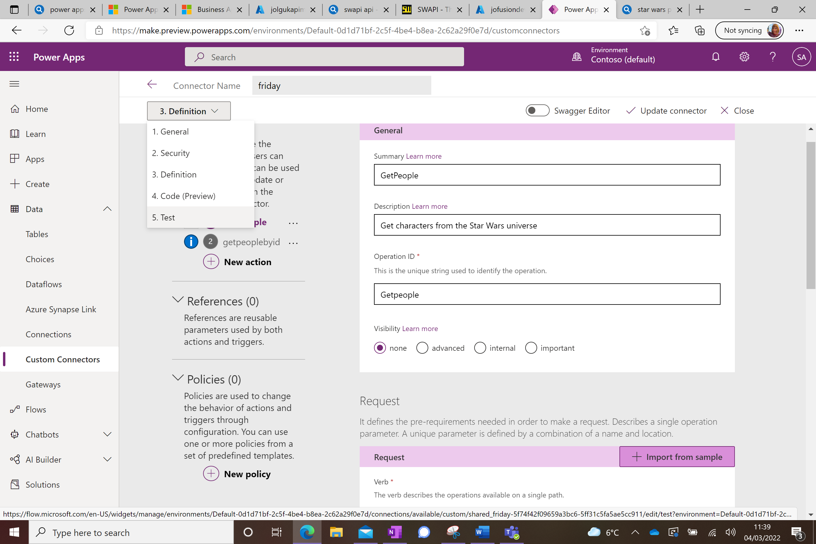

Click New Connection and select your connector, press create.

Select Custom Connectors again on the left, select your new connector and go to the Test tab. The new connection will now appear in the top box. Select Test Operation and check you get a 200 response.

Now to create an app to use this connector.

First of all download the FanClub xls file from github and upload it to your OneDrive.

Then from the make.powerapps.com Home screen, select Excel.

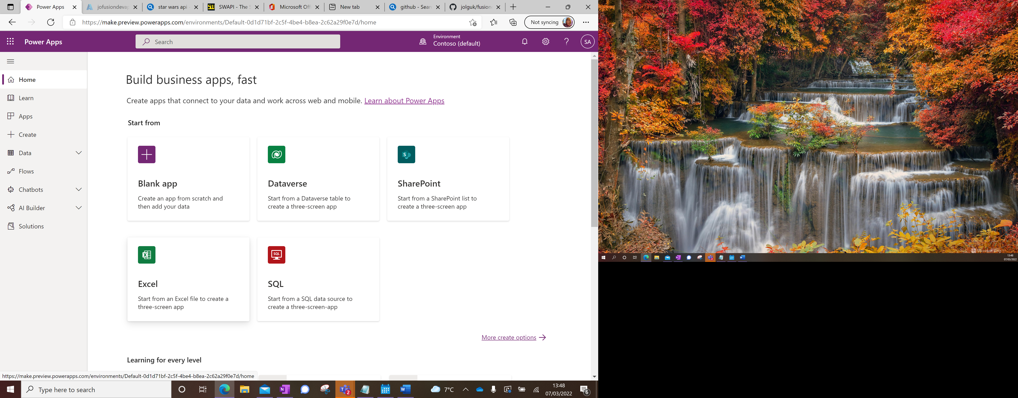

Select New Connection and make a Connection to your OneDrive. Select that connection, and then select the FanClub Excel file

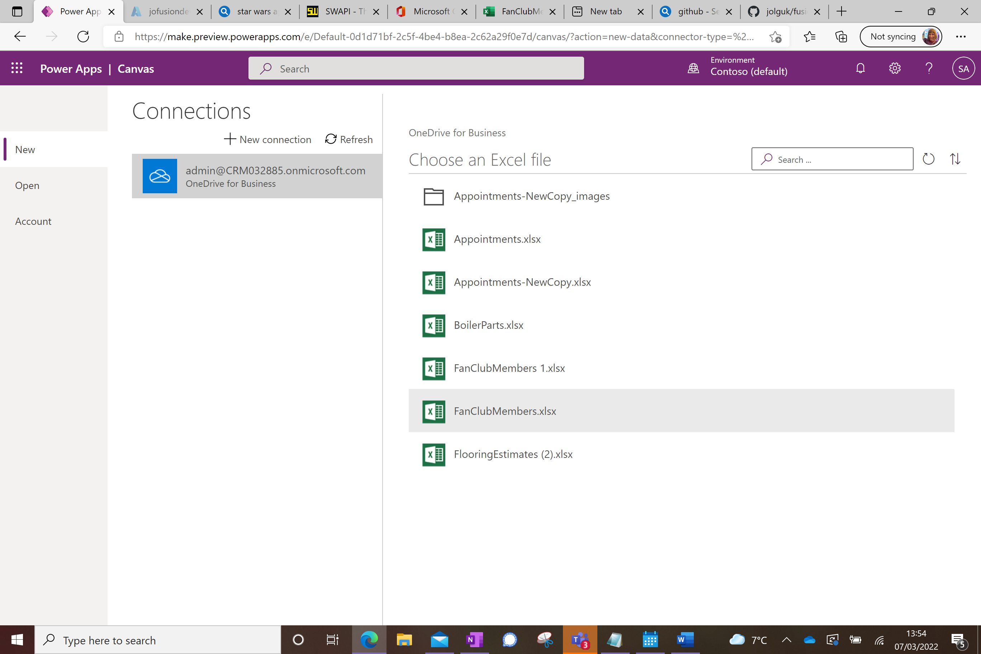

Then select the MemberList table which appears and Connect

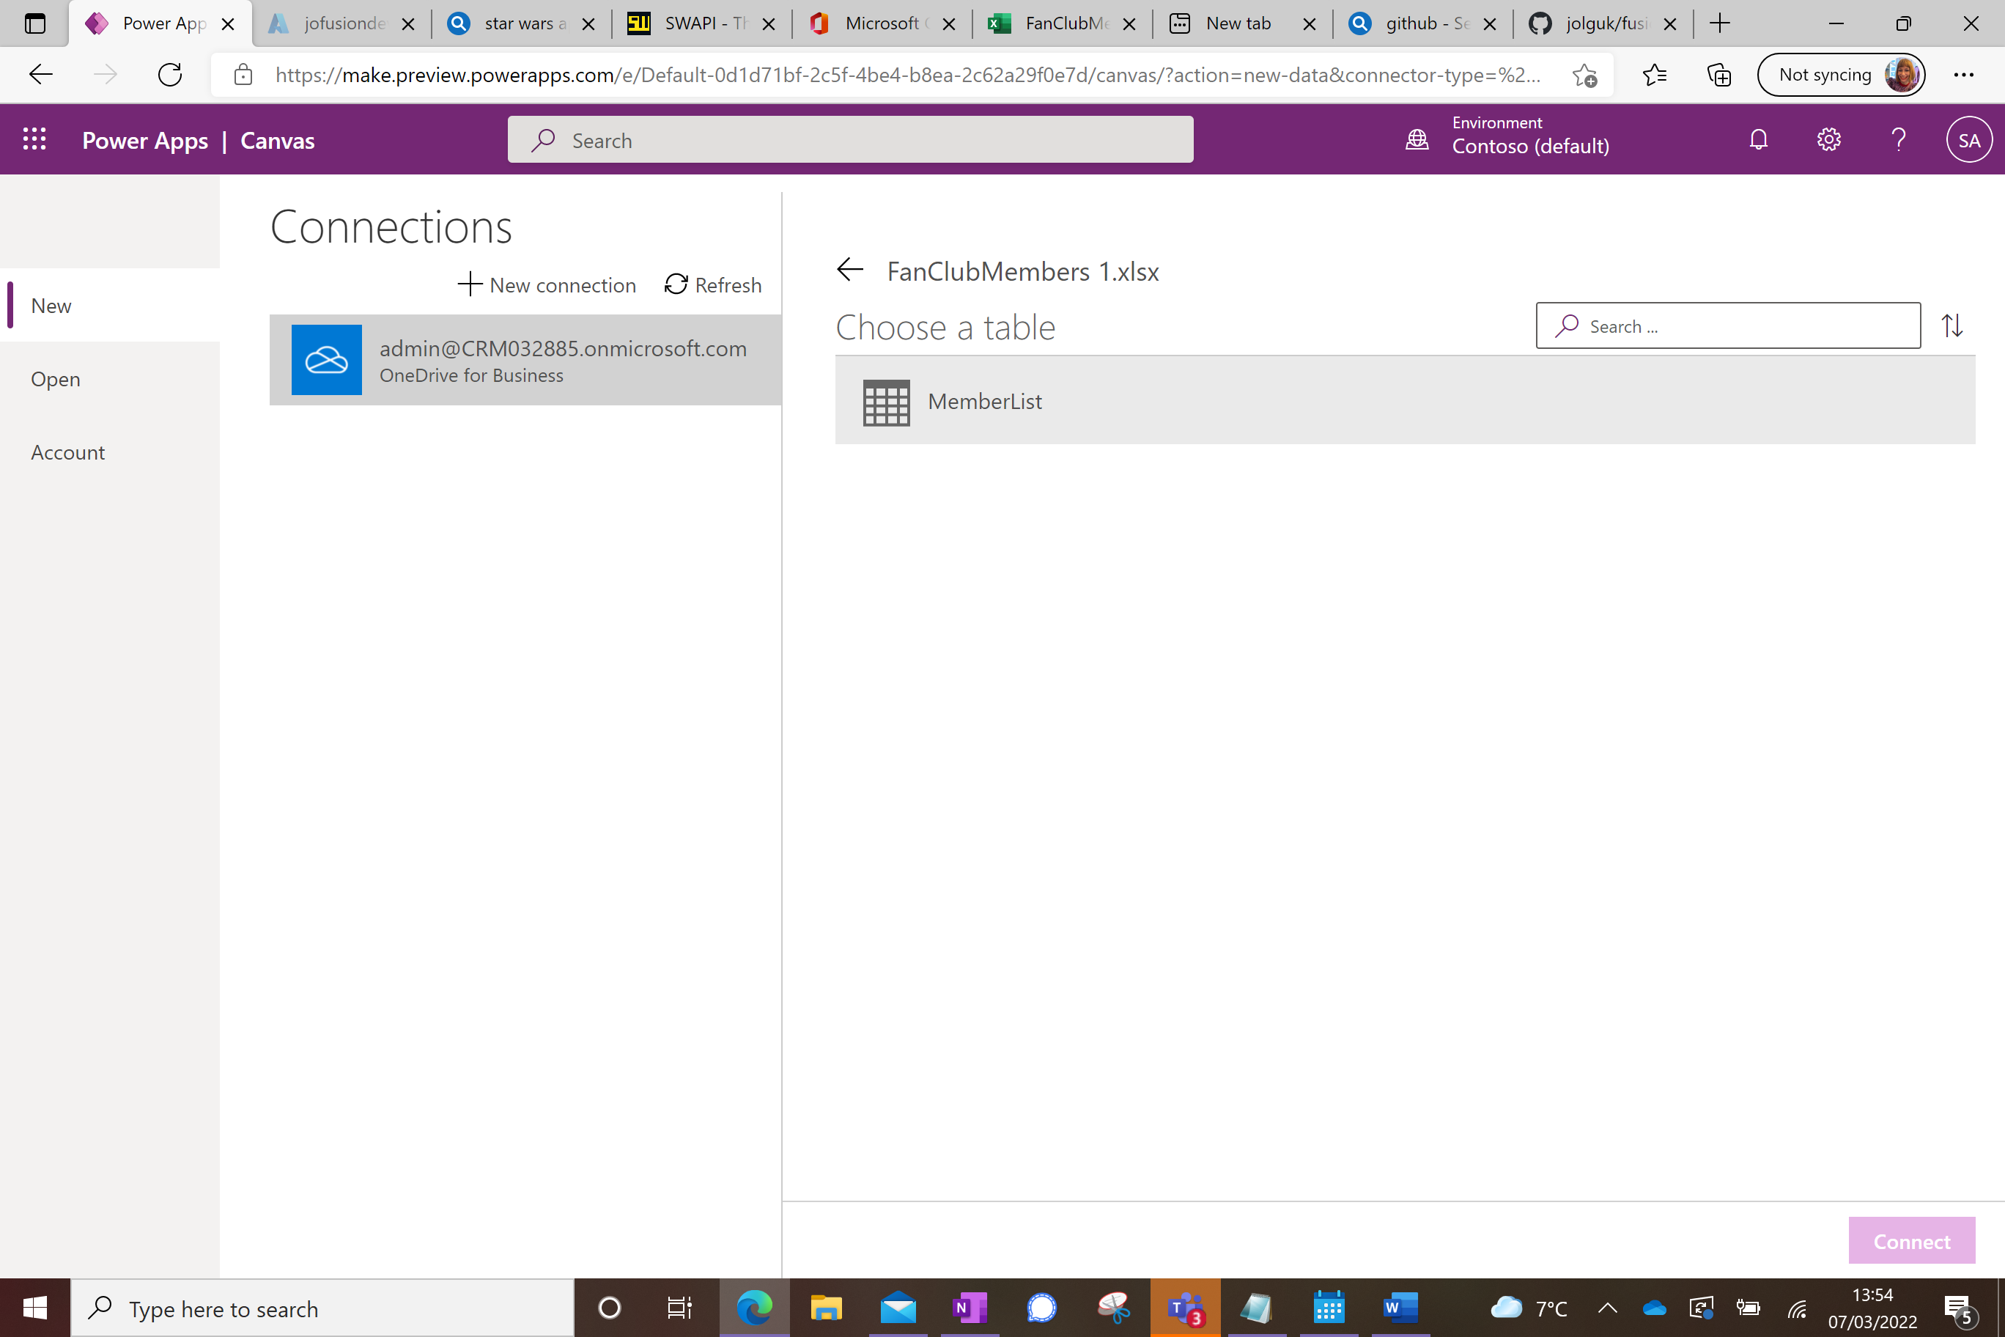The new app will be instantiated:

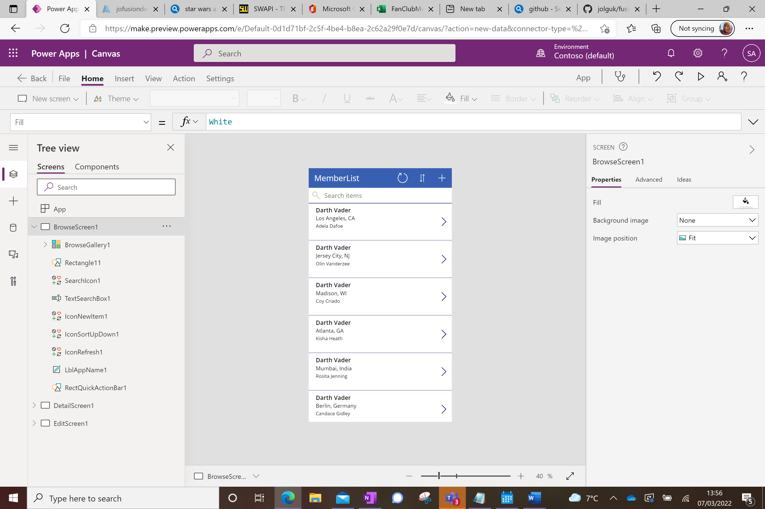

First add a connection to your new Custom Connector;

On the left, click on the database symbol, and select Add Data:

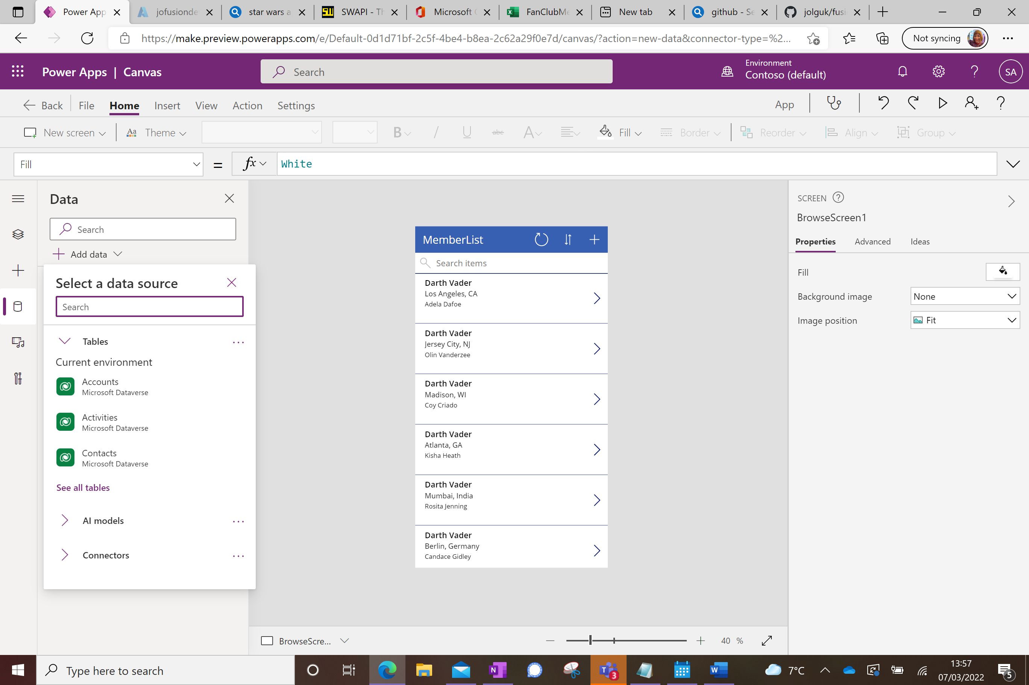

Type part of the name of your new connector into the search box, and click on it when it appears:

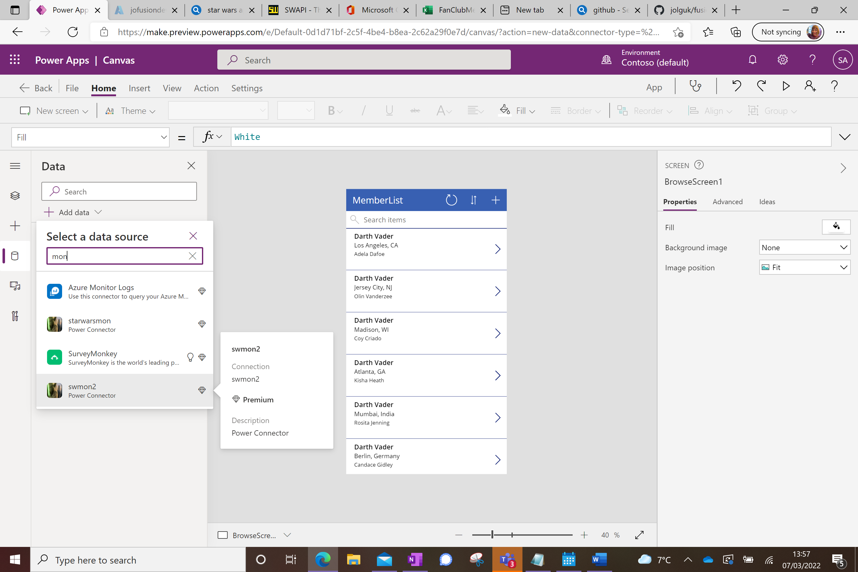

Click on it again to create a connection to it and you will see it as a Data Source alongside the Excel spreadsheet:

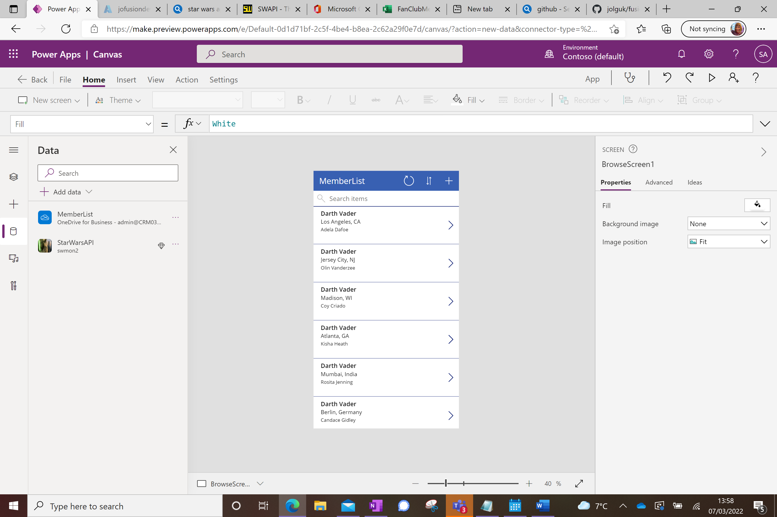

Click back onto the 3 diamonds to edit the app

Now you are in Tree View mode. Edit the fields so they show Member, Member Location, and Member Status rather than what’s there now. Select BrowseGallery1, and then on the right hand screen click Edit in the Fields section

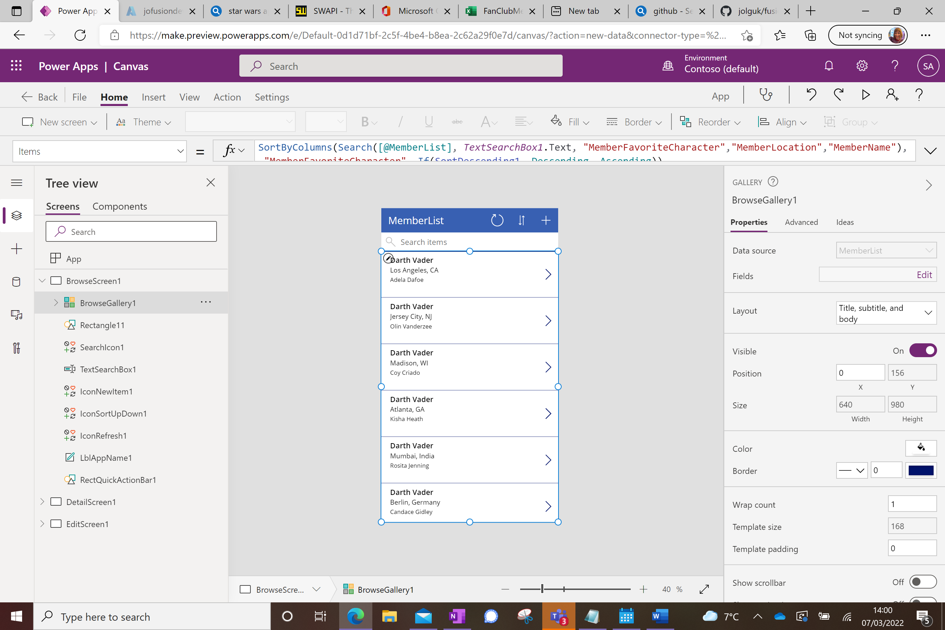

Change the Title dropdown to be Member Name and the Body dropdown to be Member Status

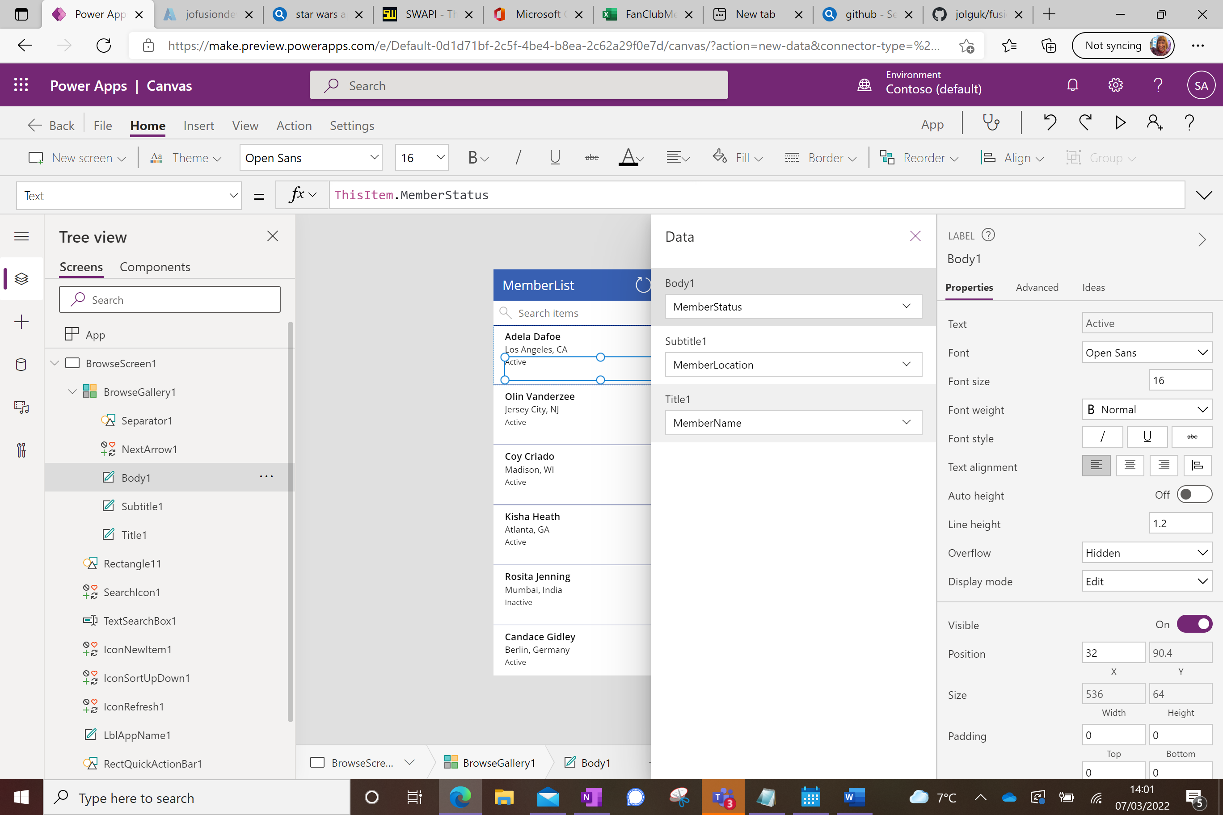

Now select the arrow to the right of the first member entry, and change the formula bar to read the following:

Navigate(DetailScreen1, None);

ClearCollect(charactersCollection, StarWarsAPI.Getpeople({search: ThisItem.MemberFavoriteCharacter}).results);

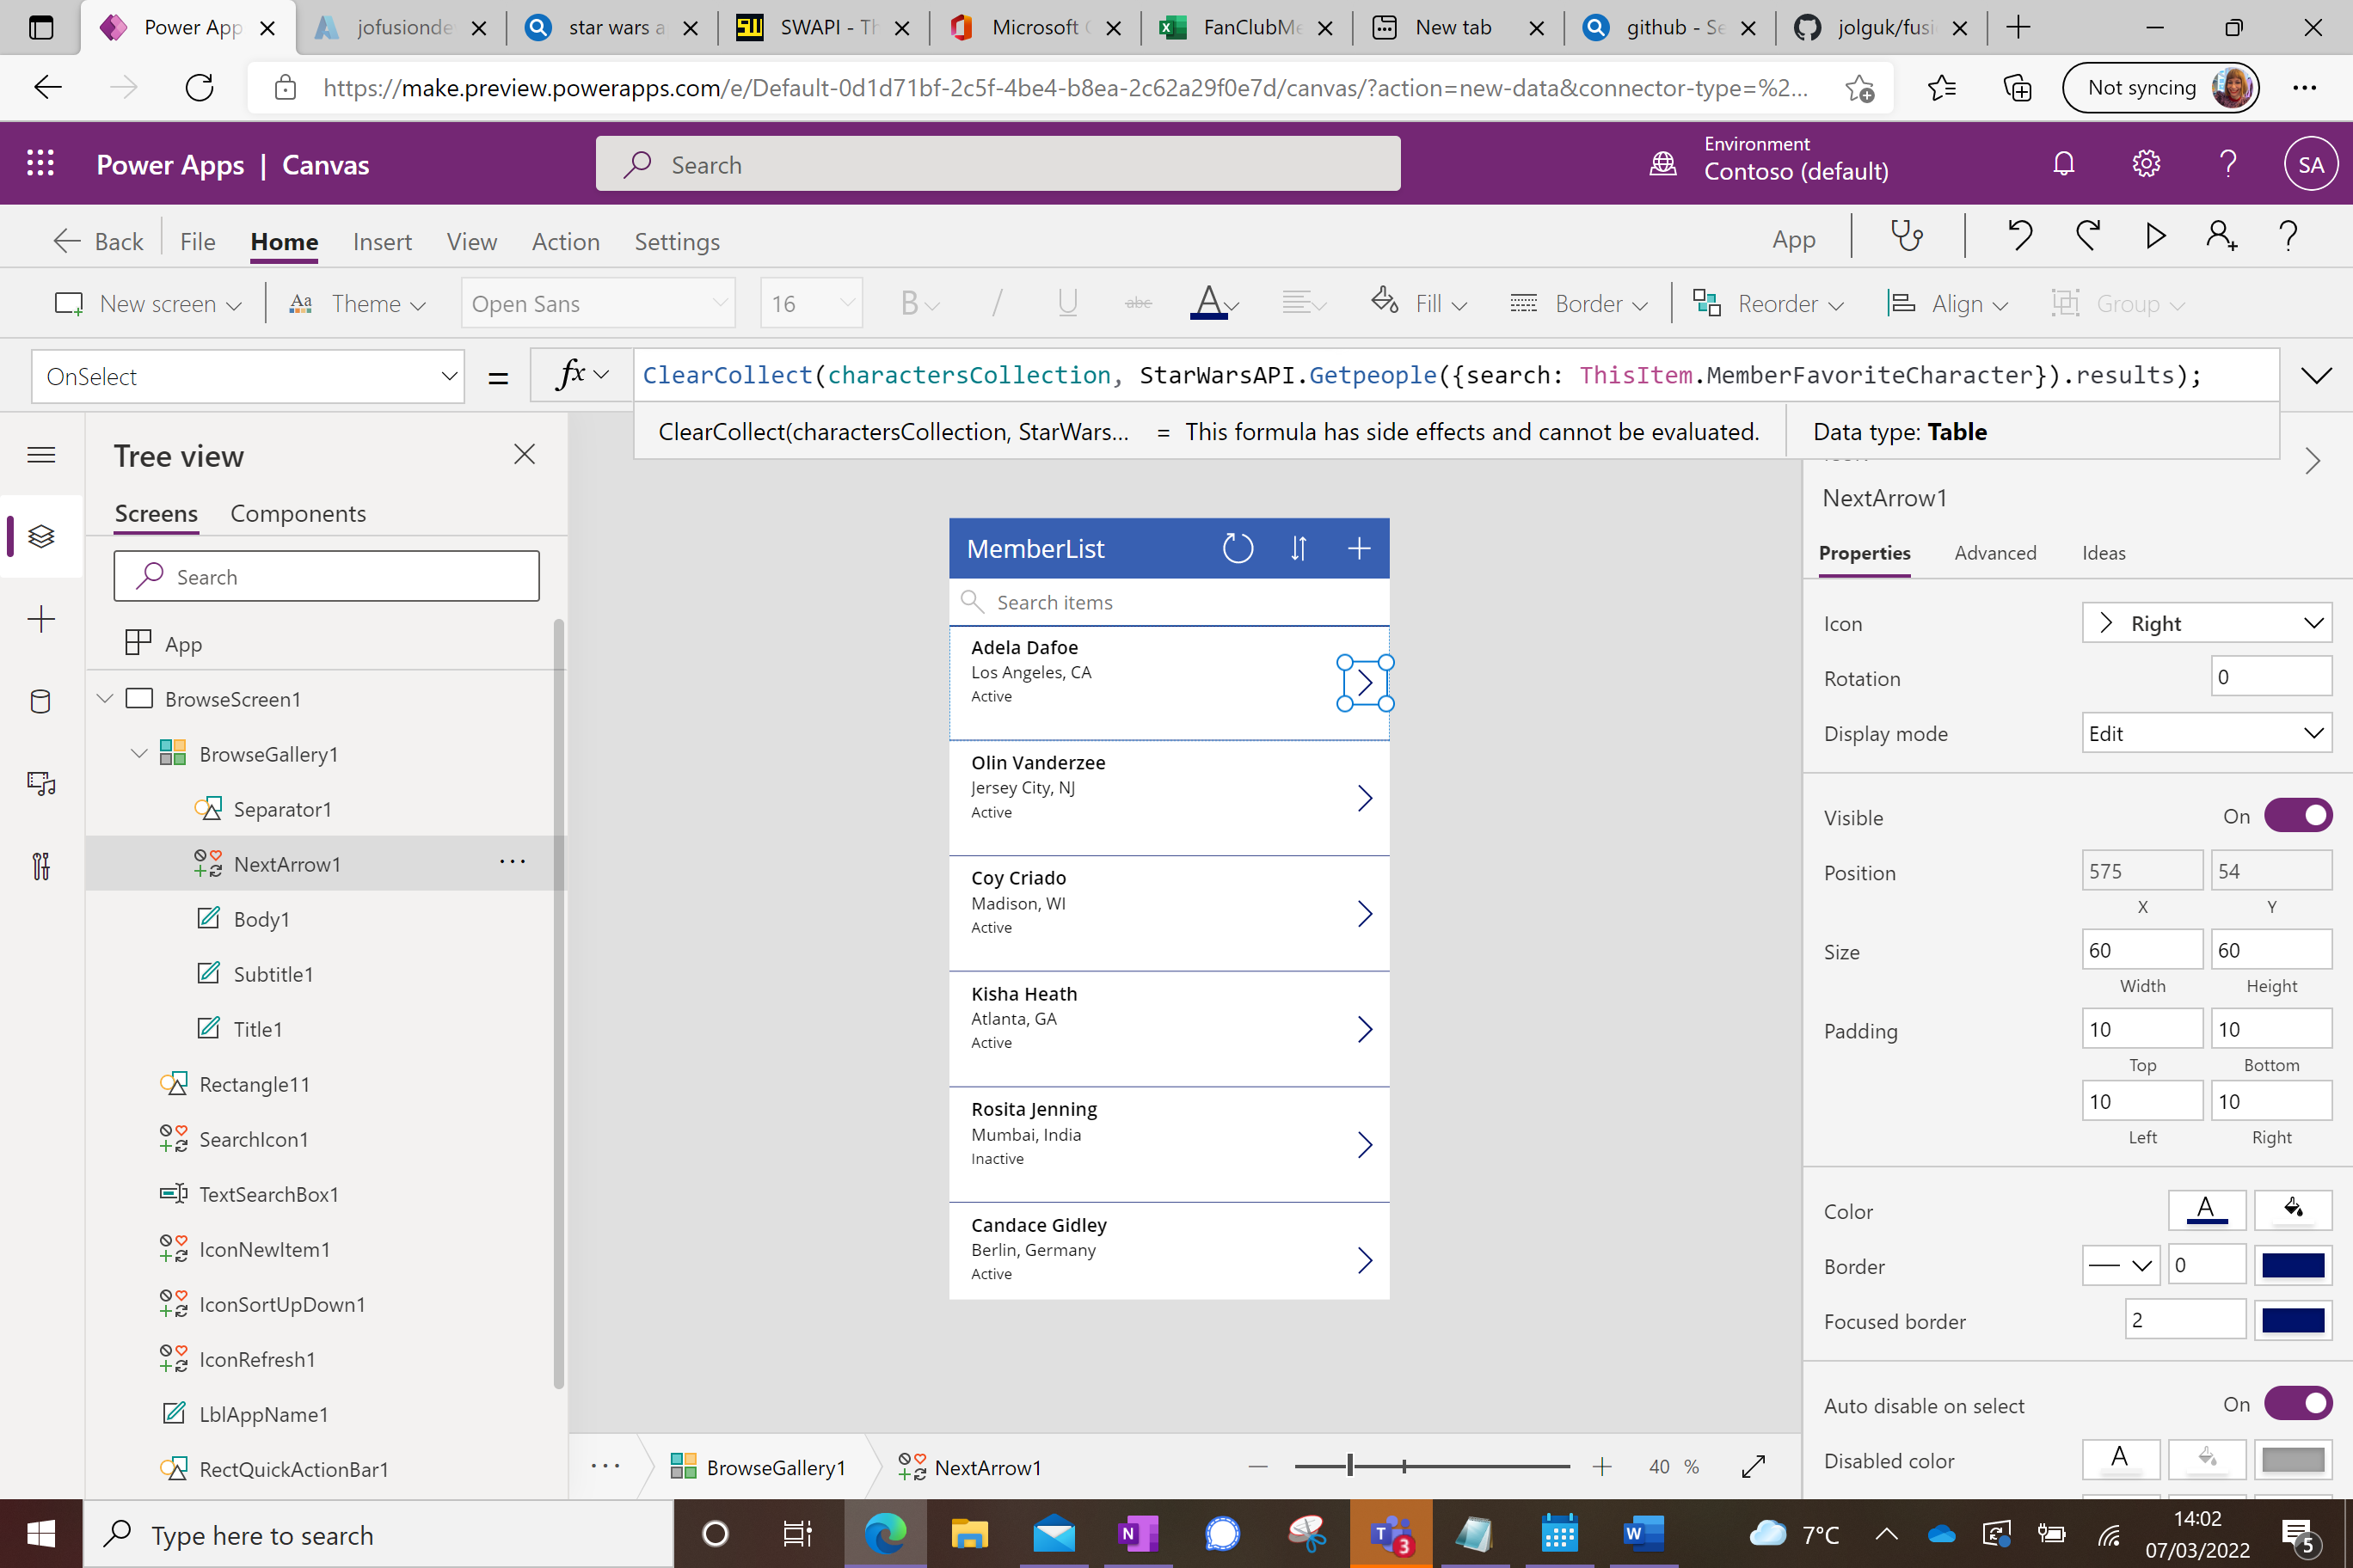

Click on DetailScreen1 on the left (you will probably have to scroll down to see it).

Create Labels to display details about the Star Wars characters:

Press Insert, then Label to create a Label and move the box to underneath the existing entries:

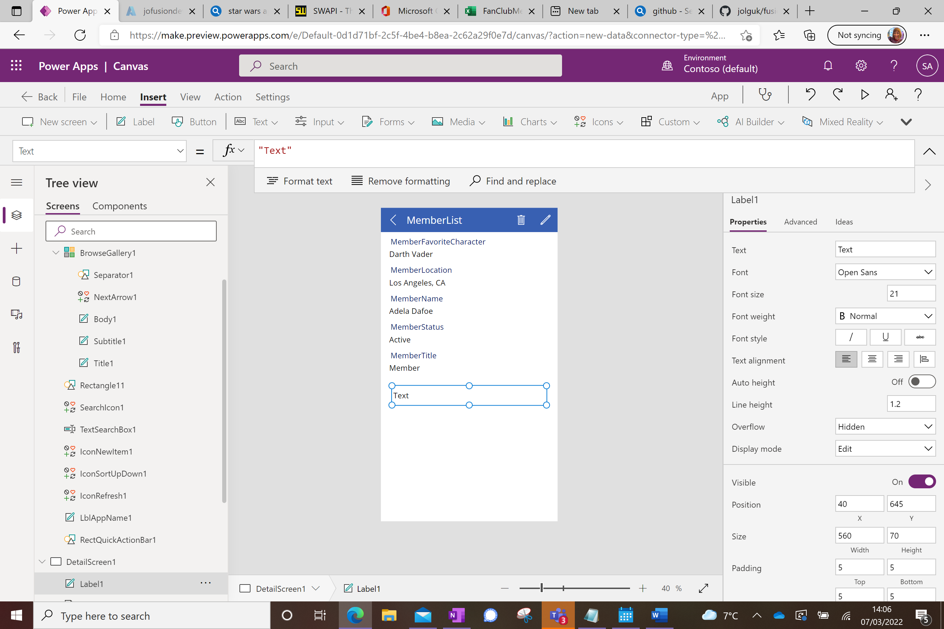

Copy that label and paste 3 times so you have 4 of them:

Label the top one ‘Name’ by typing into the Text box on the right:

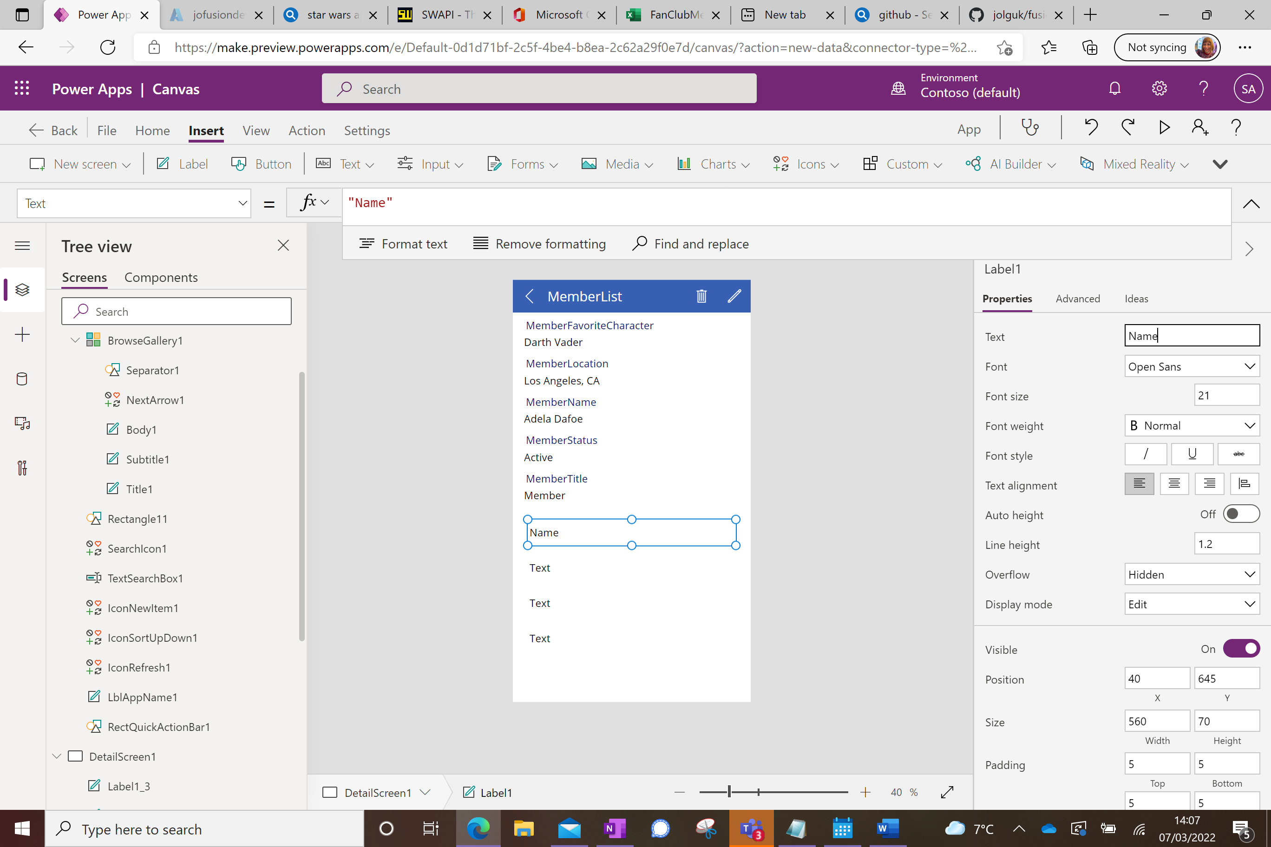

Label the 3rd one ‘Hair Colour’.

Put borders around the 2nd and 4th ones by scrolling down in the properties section and changing the number in Border from 0 to 4:

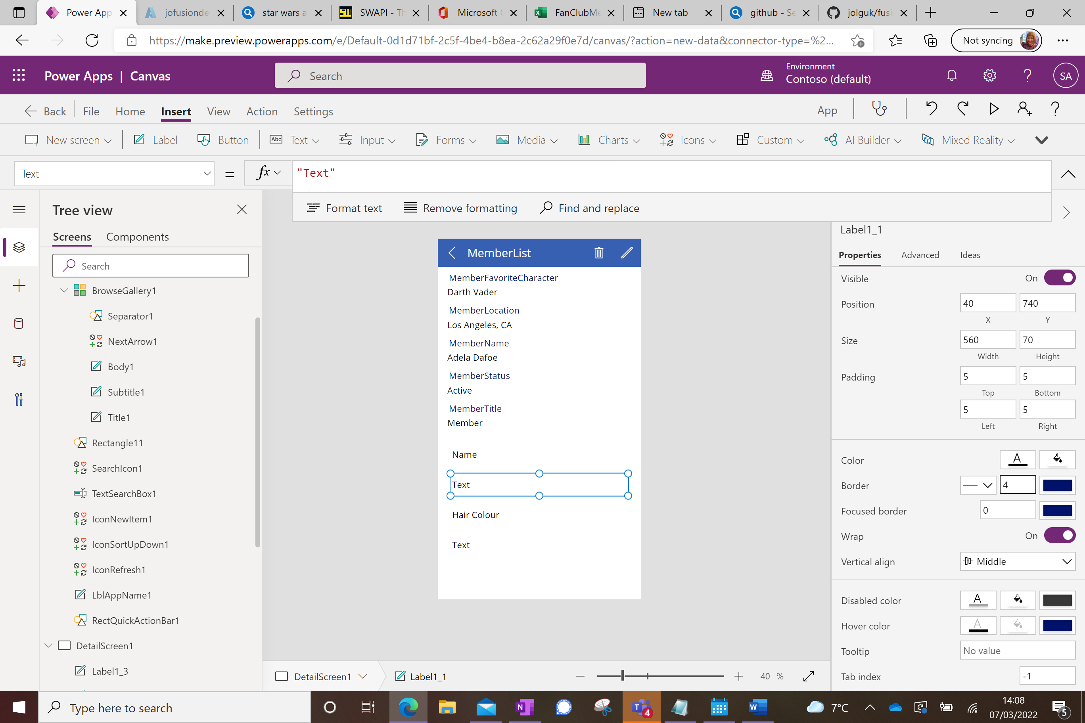

Also remove the Text from boxes 2 and 4:

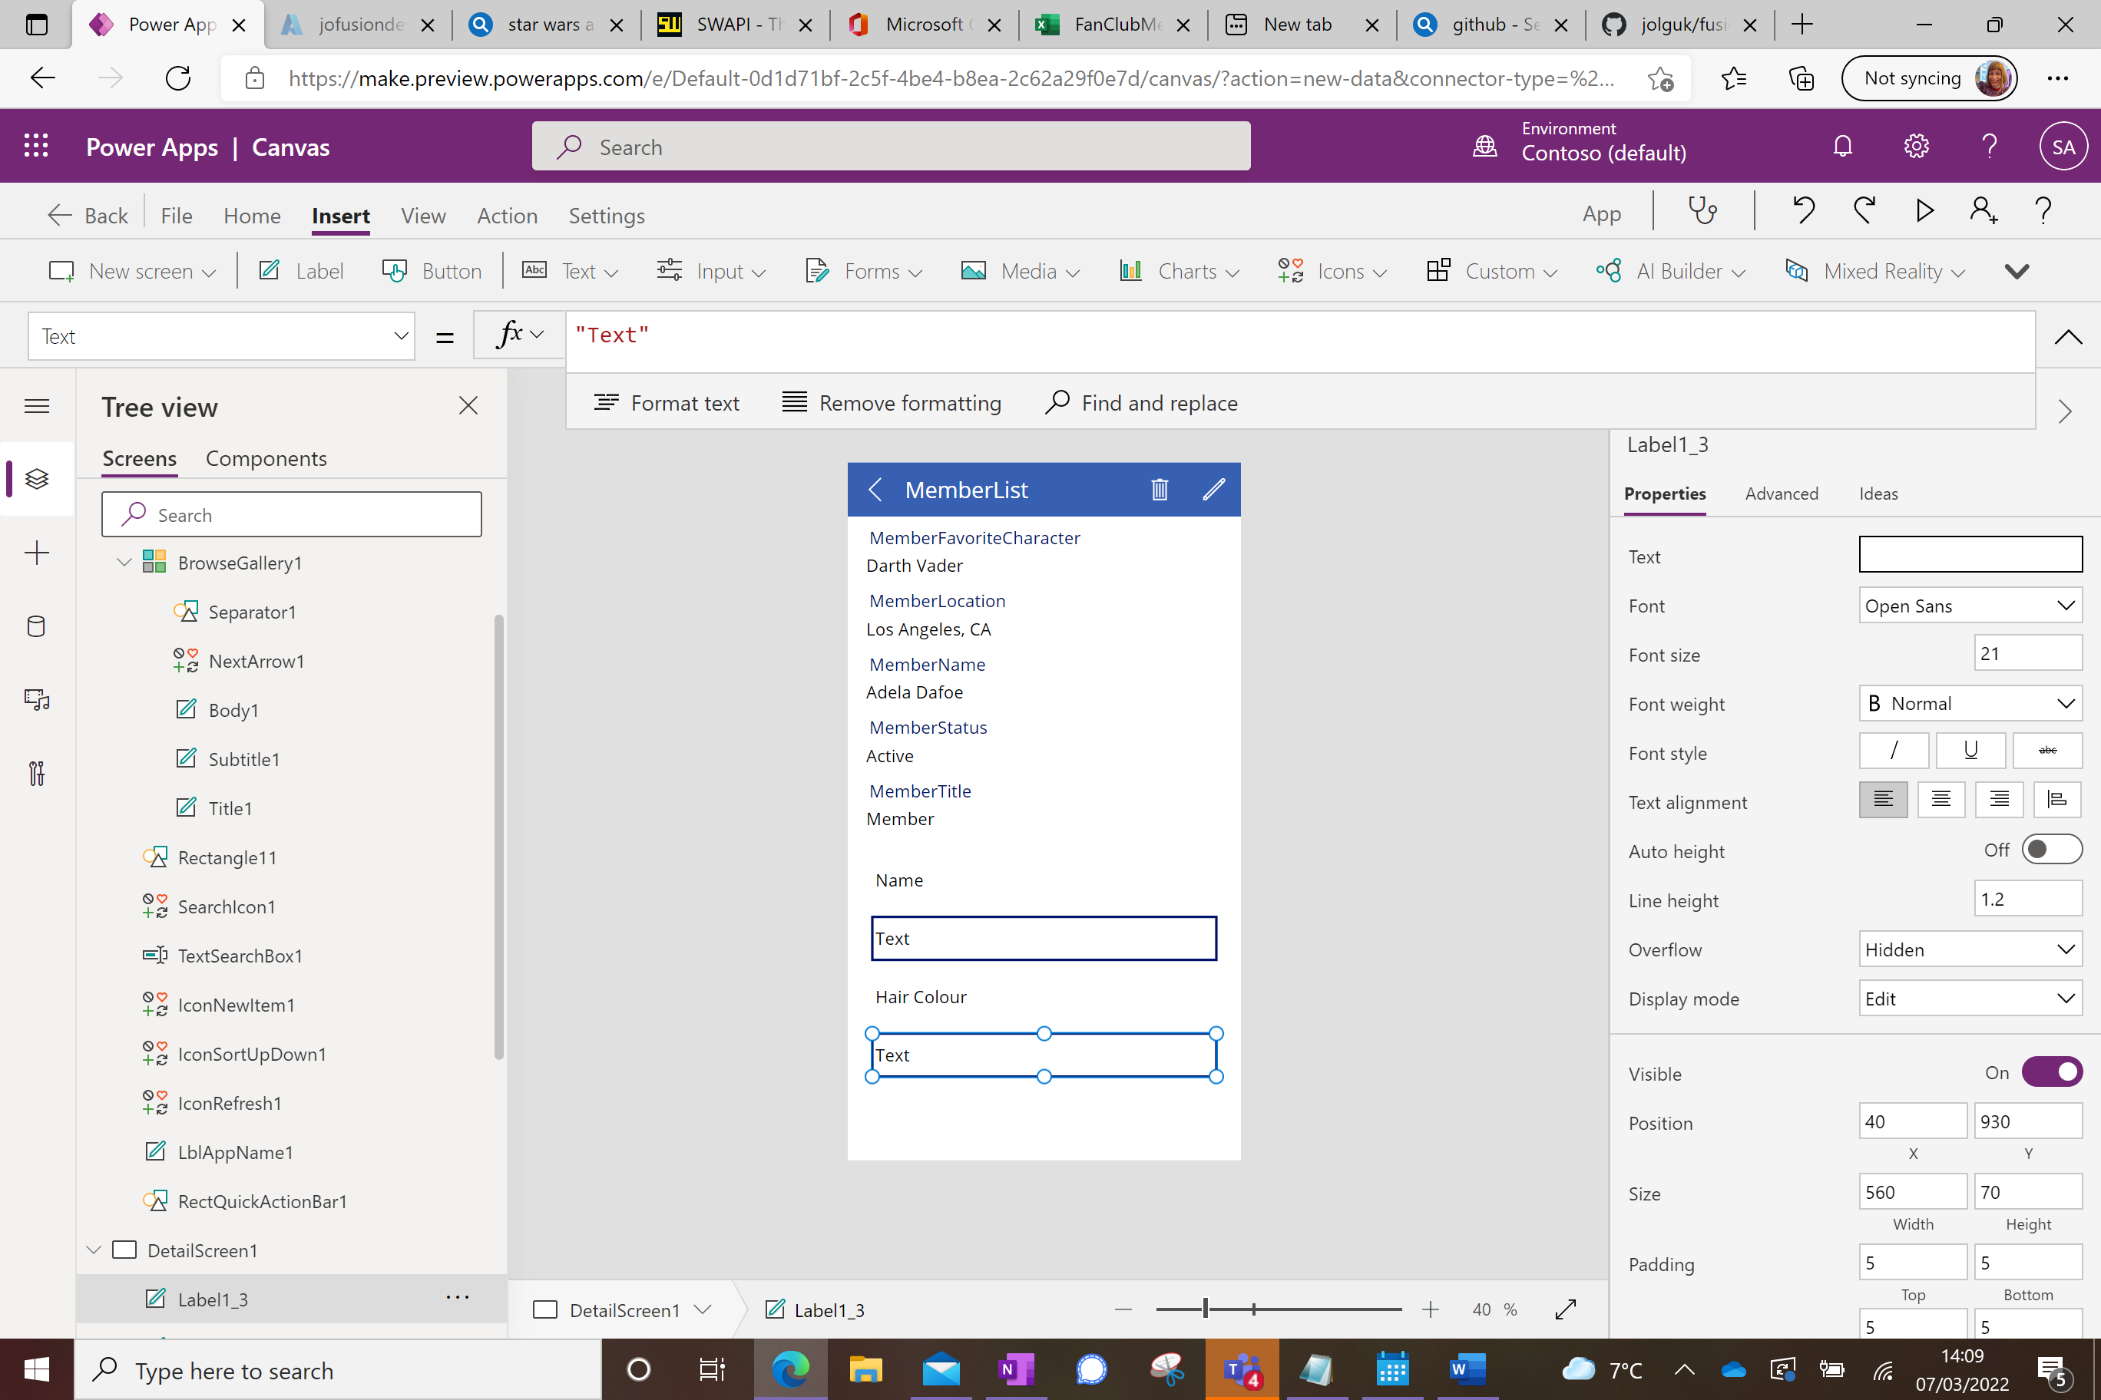

Now add the formulas to calculate the values for the bordered boxes;

Click onto the first empty box and type the following into the formula bar:

First(charactersCollection).name

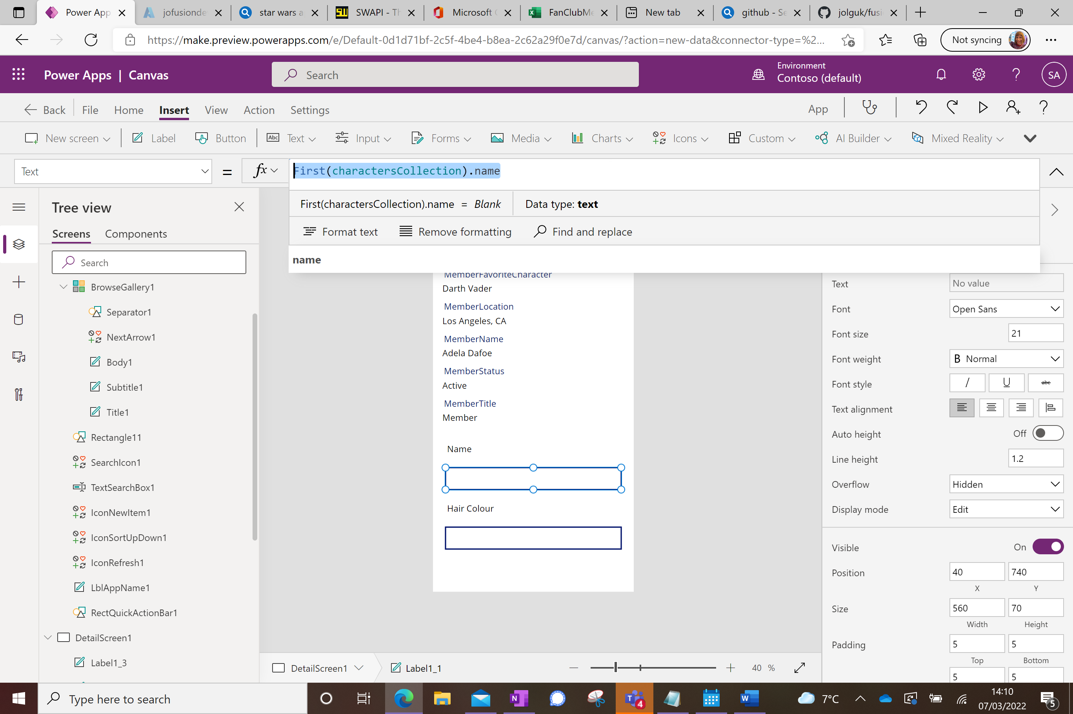

Do the same for the other box, substituting Hair_color (NB American spelling, you will be prompted as the data comes back from the collection) for Name.

Now you can play the app. Select BrowseScreen1 to return to the home page, then use the play button on the top tight. Try selecting several characters, you will probably need to scroll down to find a variety as the top few will all be Darth Vader 😊

To save your new app, select File, then Save As

